Phonics/Reading
Monday | Tuesday | Wednesday | Thursday | Friday
Play a game on Phonics Play https://www.phonicsplay.co.uk/

Write a list of words containing the sound of the day.  Mrs Penhaligan’s group: st  Mrs Hughes’ group: ai  Jade’s group: oy | Write a list of words containing the sound of the day.  Mrs Penhaligan’s group: cr  Mrs Hughes’ group: oa  Jade’s group: wh | Write a list of words containing the sound of the day.  Mrs Penhaligan’s group: fl  Mrs Hughes’ group: ee  Jade’s group: oe | Write a list of words containing the sound of the day.  Mrs Penhaligan’s group: ow  Mrs Hughes’ group: ir  Jade’s group: ew | Write a list of words containing the sound of the day.  Mrs Penhaligan’s group: th  Mrs Hughes’ group: th  Jade’s group: ck
Mrs Hughes and Jade’s group – include the alternative representations of the sounds – e.g. ai, ay, a_e in your lists
Choose a different way to practice your tricky words each day from the list below.

Rainbow write – choose a different colour for each word | Chalk them outside | Bubble write – use bubble writing | Write them in alphabetical order | Use each of your spellings in a sentence
Mrs Dunn  careful, painful, playful, restful, mouthful, beautiful, helpful, cheerful, fearful, hopeful | Mrs Rice  accident, accidentally,  address, answer,  appear, arrive  believe, bicycle  actual, actually | Mrs Penhaligan  said have like what when | Mrs Hughes  people called asked looked their | Jade  people called asked looked their
Mr Hannah’s group see Class 3 page for activity.

Reading (at least 20 minutes a day) | Read your own book or share a story together. Every few pages look at and have a go at answering 1-3 of the vipers questions – see below.  At the end of the week write a review about your favourite book. Remember to ask for sponsorship for Read for Good!

Writing
Monday | Tuesday | Wednesday | Thursday | Friday
- Talk about: What is the frog doing? Why do you think he only has one eye?  - What does cyclops mean? | Make or draw the below character – describe it to someone using adjectives. Is it a boy or girl, how are they feeling, what kind of frog are they, etc. | Draw a story map, making a plan of what will happen in your story. | Write and illustrate your story. | Share your story with someone at home.
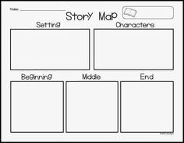

Maths
Monday | Tuesday | Wednesday | Thursday | Friday
Complete the assigned tasks on Mathletics.

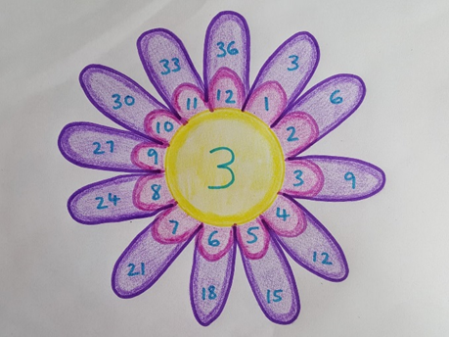
Choose a times table that you find difficult to create a flower like below. This flower is for the 3x table. You could do a few and create a ‘garden!’

