Reading - Please read for pleasure every day.
Monday | Tuesday | Wednesday | Thursday | Friday
Complete the comprehension ‘Grannie’. Click on the link for the text and questions:  https://ioeocec.exampro.net/ |  | Complete the grammar activity below.  https://belowug.exampro.net/ | Complete spelling activities at https://spellingframe.co.uk/

Writing
Monday | Tuesday | Wednesday | Thursday | Friday
- Talk about: Why are the orangutans in the wheelbarrow? Where are their parents?  - How are they feeling? | Vocabulary: create a list of adjectives that describe the looks and emotions of the orangutans. | Success Criteria: create a success criteria that you will use to help guide you in describing the orangutan’s appearance and feelings | Draft: take a first attempt at describing the orangutans | Edit/Present: edit your writing from yesterday and re-write focusing on your handwriting.
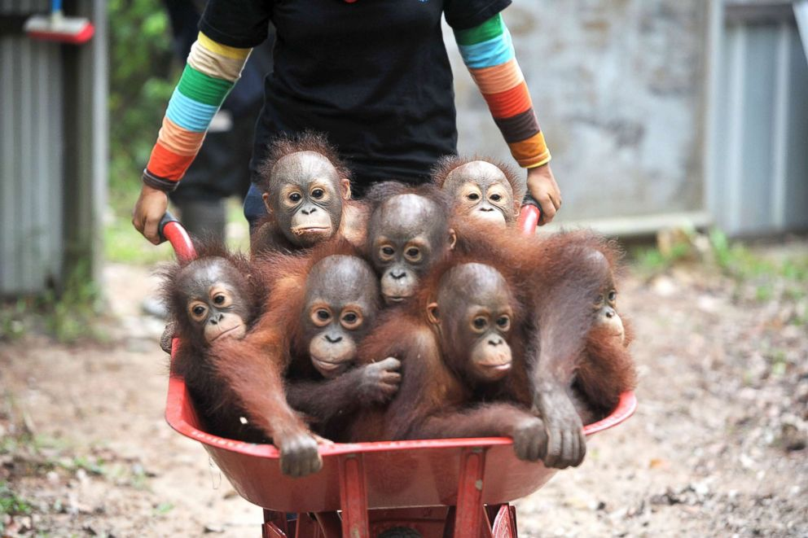

Maths
Monday | Tuesday | Wednesday | Thursday | Friday
Complete the assigned tasks on Mathletics.
