Wider Curriculum
Below is a list of suggested activities – you may have your own ideas and projects that you want to try.

Log in as a guest or sign up to code.org and have a go at computer programming.  https://code.org/ | Make a picture using natural materials.  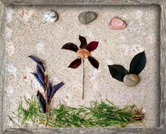 | Design a new Easter egg. What flavour would it be? Is there anything inside? What will the wrapper look like? |  | Plan a menu for a party for your family and help to make the food. Find out where all of the ingredients come from.
Learn the capital cities of 10 countries that you never knew before. | Email Mr Hannah @ head@duloeprimary.co.uk and let me know what you have been up to. | Watch the video about Easter at  https://www.bbc.co.uk/bitesize/topics/ztkxpv4/articles/z4t6rj6 |  | Set up a fitness circuit in the garden or house. Ask an adult to time you, can you get faster and faster? Challenge the adult to try and beat your time.
Design your dream house. Would you have an indoor basketball court? A chocolate-room? Floors that are trampolines? Be as wacky and creative as you can be! | Joe Wickes is running online PE sessions daily at 9am: https://www.youtube.com/channel/UCAxW1XT0iEJo0TYlRfn6rYQ |  | Think of examples where you have shown our school values since you have been at home.  Compassion, Creativity, Friendship, Perseverance and Respect.

