Home Learning 2
Q1. (Year 4 standard)
This pictogram shows the number of satellites above the Earth in 2016.
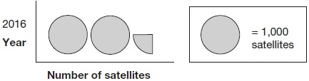
How many satellites were above the Earth in 2016?
1 mark
Q2. (Year 4 standard)

William asks the children in Year 2 and Year 6 if they walk to school.
This graph shows the results.
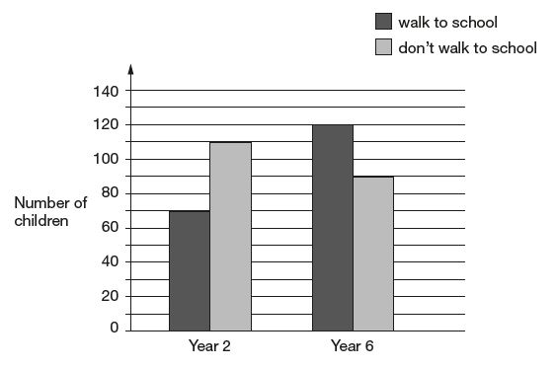
Altogether, how many children don’t walk to school?
1 mark
How many more Year 6 children than Year 2 children walk to school?
1 mark
Q3. (Year 4 standard)

A school plans to collect £200 between January and May.
This chart shows how much they collected by the end of April.

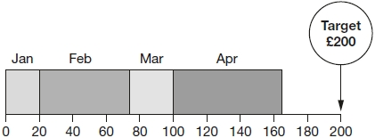
Amount of money collected in £
Write the name of each month where they collected more than £50
___________________________________________________________________
1 mark
How much money did they collect in February and March altogether?

1 mark

Q4. (Year 4 standard)

Amy went on a cycling holiday.
This chart shows how far she cycled each day.

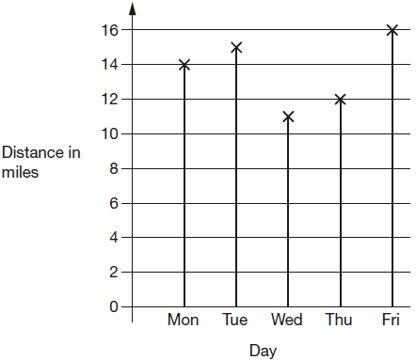

How much further did Amy cycle on Friday than on Wednesday?
1 mark
How far did Amy cycle altogether on the three days she cycled the most?
1 mark

Q5. (Year 4 standard)

Class 6 did a survey of mushrooms growing in a field.
The diagram shows the distances of mushrooms from the centre of the field.

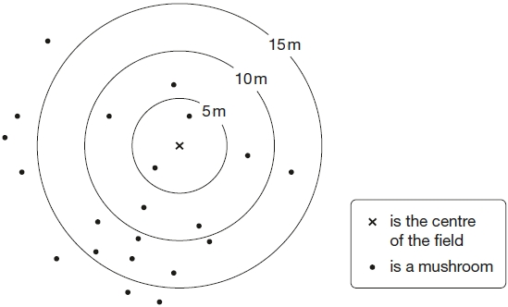
How many mushrooms were more than 10 metres from the centre?
1 mark
What fraction of the mushrooms were less than 10 metres from the centre?
1 mark

Q6. (Year 5 standard)

This graph shows the temperature in °C from 2 am to 3 pm on a cold day.
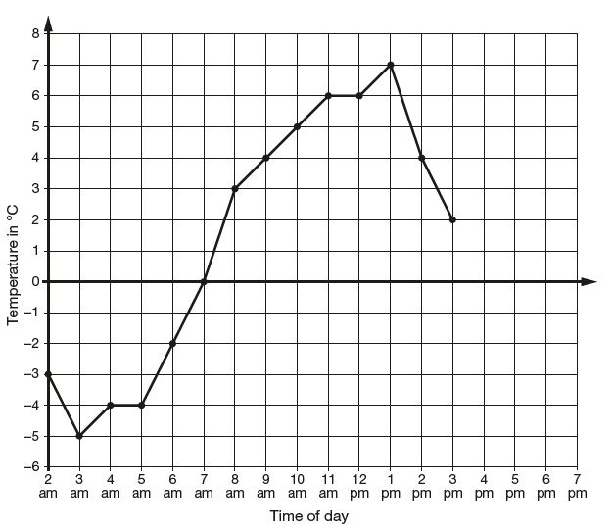
How many degrees warmer was it at 3 pm than at 3 am?
1 mark
At 6 pm the temperature was 4 degrees lower than at 3 pm.
What was the temperature at 6 pm?
1 mark

Q7. (Year 5 standard)

This table shows the heights of three mountains.

Mountain | Height in metres
Mount Everest | 8,848
Mount Kilimanjaro | 5,895
Ben Nevis | 1,344
How much higher is Mount Everest than the combined height of the other two mountains?
2 marks
Q8. (Year 5 standard)

William wants to travel to Paris by train.
He needs to arrive in Paris by 5:30 pm.
Circle the latest time that William can leave London.

Leaves London | Arrives Paris
12:01 | 15:22
12:25 | 15:56
13:31 | 16:53
14:01 | 17:26
14:31 | 17:53
15:31 | 18:53
16:01 | 19:20
1 mark
Q9. (Year 5 standard)

This table shows the number of people living in various towns in England.

Town | Population
Bedford | 82,448
Carlton | 48,493
Dover | 34,087
Formby | 24,478
Telford | 166,640
What is the total of the numbers of people living in Formby and in Telford?
1 mark
What is the difference between the numbers of people living in Bedford and in Dover?
1 mark
Q10. (Year 5 standard)

Here is the morning timetable for Chen’s class this week.

Time | Mon | Tue | Wed | Thu | Fri
9:00 am – 10:30 am | Maths | English | Maths | English | Maths
10:30 am – 11:00 am | Break | Break | Break | Break | Break
11:00 am – 12:00 pm | English | Maths | Science | Maths | English
What is the total number of hours for English on this timetable?
1 mark

Q11. (Year 6 standard)
Here are the temperatures in four cities at midnight and at midday.

 | Temperature
City | At midnight | At midday
Paris | −4°C | −2°C
Oslo | −13°C | −7°C
Rome | 3°C | 10°C
Warsaw | −6°C | 2°C
At midnight, how many degrees colder was Paris than Rome?
1 mark
Which city was 6 degrees colder at midnight than at midday?
________________________
1 mark
Q12. (Year 6 standard)
This chart shows the number of different types of big cat in a zoo.
There are 20 big cats in the zoo altogether.
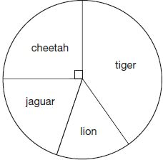
Here are some statements about the chart.
Tick the statements that are true.

There are more cheetahs than jaguars.
The total number of lions and tigers is 10
One-quarter of the big cats are cheetahs.
There are more than 5 jaguars.
2 marks
Q13. (Year 6 standard)

Seven children measured their heights.

Children | Height (cm)
Stefan | 144
Lara | 136
Olivia | 142
Chen | 143
Maria | 152
Dev | 148
Sarah | 150
What is the mean height of the children?

2 marks

Q14. (Year 6 standard)

This weather chart shows the highest and lowest temperatures in a town on five days in March.

 | Temperature °C
 | highest | lowest
Monday | +7 | 0
Tuesday | +7 | –2
Wednesday | +8 | –2
Thursday | +9 | +1
Friday | +4 | –5
Which day has the greatest difference between the highest and the lowest temperatures?
_________________________
1 mark
What is the difference between the lowest temperatures on Thursday and Friday?
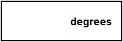
1 mark

Q15. (Year 6 standard)

Write each number in its correct place on the diagram.
16 17 18 19
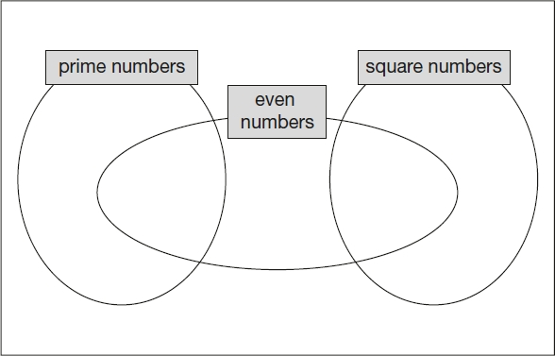
2 marks

Mark schemes
Q1.
2,250
Do not accept OR OR 2.25
[1]
Q2.

(a) 200
1
(b) 50
1
[2]
Q3.
(a) February and April in either order.
Accept alternative unambiguous indications, e.g. F and A.
Do not accept the amounts collected in February and
April, i.e. £55 and £65
1
(b) £80
1
[2]
Q4.
(a) 5
1
(b) 45
1
[2]
Q5.
(a) 14
1
(b)
Accept equivalent fractions eg
Ignore subsequent work if is simplified incorrectly.
Accept follow through in part (b) of 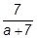
1
[2]
Q6.

(a) 7
1
Do not accept −7 or 7−
(b) −2
1
Do not accept 2−
[2]
Q7.

Award TWO marks for the correct answer of 1,609
If the answer is incorrect, award ONE mark for evidence of an appropriate method, e.g.
• 5,895 + 1,344 = 7,239
8,848 − 7,239
Answer need not be obtained for the award of ONE mark.
Up to 2m
[2]
Q8.

The correct time circled as shown:
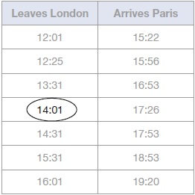
Accept alternative unambiguous positive indications, e.g. 14:01 ticked or underlined.
Accept 17:26 circled in addition to 14:01, provided no other time is circled.
Do not accept only the arrival time 17:26 circled.
[1]
Q9.

(a) 191,118
1
(b) 48,361
1
[2]
Q10.

5
Do not accept 300 (minutes).
[1]
Q11.
(a) 7
Do not accept −7 or 7−
1
(b) Oslo
Accept unambiguous abbreviations or recognisable misspellings.
1
[2]
Q12.
Award TWO marks for only two correct boxes ticked, as shown:

There are more cheetahs than jaguars.
The total number of lions and tigers is 10
One-quarter of the big cats are cheetahs.
There are more than 5 jaguars.
Award ONE mark for:
• only one correct box ticked and no incorrect boxes ticked
OR
• two correct boxes ticked and one incorrect box ticked.
Accept alternative unambiguous positive indications, e.g. Y.
Up to 2 marks
[2]
Q13.
Award TWO marks for the correct answer of 145
If the answer is incorrect, award ONE mark for evidence of an appropriate method, e.g:
• 144
136
142
143
152
148
+ 150
1015
1015 ÷ 7
Answer need not be obtained for the award of ONE mark.
Up to 2
[2]
Q14.
Wednesday
Accept unambiguous abbreviations or recognisable misspellings.
1
6
Do not accept −6
1
[2]

Q15.

Award TWO marks for all four numbers placed correctly as shown:
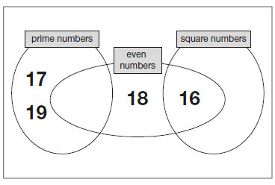
If the answer is incorrect, award ONE mark for three numbers placed correctly.
Accept alternative unambiguous indications, e.g. lines drawn from the numbers to the appropriate regions of the diagram.
Do not accept numbers written in more than one region, e.g.
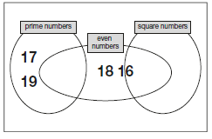
OR
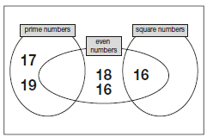
Up to 2m
[2]

