Phonics/Reading
Monday | Tuesday | Wednesday | Thursday | Friday
Play a game on Phonics Play https://www.phonicsplay.co.uk/

Reception – Sign up to https://www.teachyourmonstertoread.com/

Bank Holiday | Write a list of words containing the sound of the day.  Mrs Adrew/Lynsey group: ng  Mrs Penhaligan’s group: sp  Mrs Hughes’ group: str  Jade’s group: ou | Write a list of words containing the sound of the day.  Mrs Adrew/Lynsey group: qu  Mrs Penhaligan’s group: bl  Mrs Hughes’ group: pr  Jade’s group: ie | Write a list of words containing the sound of the day.  Mrs Adrew/Lynsey group: ai  Mrs Penhaligan’s group: fr  Mrs Hughes’ group: nch  Jade’s group: ea | Write a list of words containing the sound of the day.  Mrs Adrew/Lynsey group: ee  Mrs Penhaligan’s group: nd  Mrs Hughes’ group: ew  Jade’s group: ir
Mrs Hughes and Jade’s group – include the alternative representations of the sounds if there are any – e.g. ai, ay, a_e in your lists

Choose a different way to practice your tricky words each day from the list below.

Rainbow write – choose a different colour for each word | Chalk them outside |  | Bubble write – use bubble writing |  | Write them in alphabetical order |  | Use each of your spellings in a sentence
Mrs Andrew/ Lynsey  we me be my |  | Mrs Penhaligan  was they are all |  | Mrs Hughes  some were little could |  | Jade  some were little could

Reading (at least 20 minutes a day) | Read your own book or share a story together. Every few pages look at and have a go at answering 1-3 of the vipers questions – see below.  At the end of the week write a review about your favourite book. Remember to ask for sponsorship for Read for Good!

Writing
Monday | Tuesday | Wednesday | Thursday | Friday
Bank Holiday | Keep a diary for the week. Each day write about something and illustrate. It will be great to see what everyone has got up too. I will keep a diary too. Below are some suggestions for writing ideas that you might include.
Year 1 focus activities for each day. | Looked at the jumbled up nursery rhymes. Can you write them out/cut and stick them into the correct order? A diary needs to be written in order. Day 1 entry - Write your first entry. | Read Day 1 and edit if you need to.  Day 2 entry – can you include some adjectives to make your writing more descriptive – “I saw a little, red ladybird with six black spots.” | Day 3 entry – Can you used connectives to join your ideas together – “We played catch in the garden but I dropped the ball.” “I phoned my Grandma and told her about my Easter hunt.” | Day 4 entry – Today can you use time words to help explain your day? “After breakfast I read my reading book then I had a snack.” “Before tea I made a Lego model.”  Make your diary into a book with a front cover.
Someone you have spoken to. | Something you have seen outside. | A game that you have played. | Your favourite meal of the day. | A programme that you have watched.
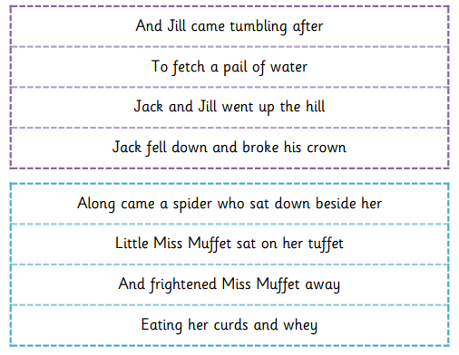
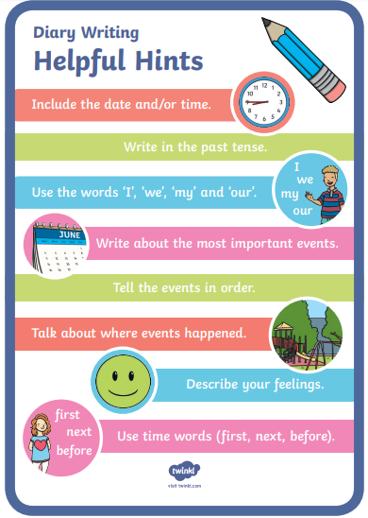

Maths
Monday | Tuesday | Wednesday | Thursday | Friday
Complete the assigned tasks on Mathletics.

Roll 2 dice and add the numbers together. If you want it trickier try using 3 or 4! |  | Use empty bottles to make skittles. Give each bottle a number – how many points can you score. | Go on Supermovers and challenge Webster to count in 10’s.  https://www.bbc.co.uk/teach/supermovers/ks1-maths-the-10-times-table-with-webster-the-spider/zm32cqt

