Wider Curriculum
Below is a list of suggested activities – you may have your own ideas and projects that you want to try.

Log in as a guest or sign up to code.org and have a go at computer programming.  https://code.org/ |  | Make a stick person – add material and natural bits from the garden.  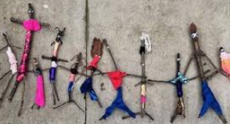 |  | Make a den for your stick person. |  | Use tubes to make some binoculars. Take them out in the garden or for a walk and see what you can spot.  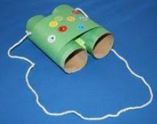
Plan a menu for a party for your family and help to make the food. Find out where all of the ingredients come from. | Make a picture using natural materials.  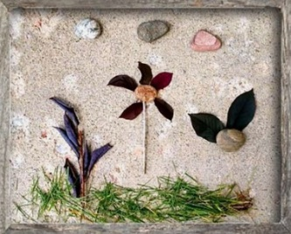 |  | Watch the video clip about the events of Easter Sunday. Draw and write about what you find out.  https://www.bbc.co.uk/cbeebies/stories/lets-celebrate-easterperformance |  |  |  | Design a new Easter egg. What flavour would it be? Is there anything inside? What will the wrapper look like?
Can you make, draw, paint or chalk a rainbow to display inside your window or outside your house to make your neighbours smile? |  | Joe Wicks has been running online PE sessions daily at 9am they are great for all of the family to get you up and moving in the morning. https://www.youtube.com/channel/UCAxW1XT0iEJo0TYlRfn6rYQ |  |  | 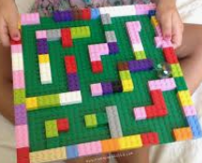  Make a marble maze with Lego.

