Home Learning 3
Q1. (Y4 Standard)

Here are five angles marked on a grid of squares.
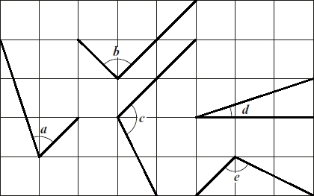
Write the letters of the angles that are obtuse.
________________________
1 mark
Write the letters of the angles that are acute.
________________________
1 mark

Q2. (Y4 Standard)

A triangle is translated from position A to position B.
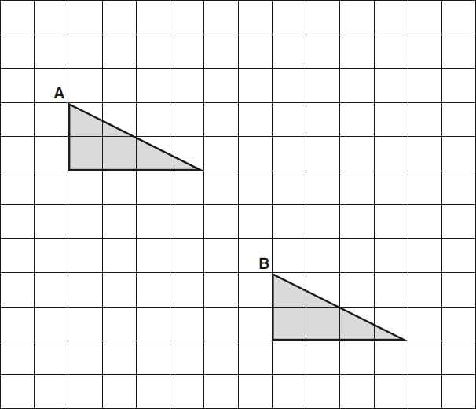
Complete the sentence.

The triangle has moved |  | squares to the right
and |  | squares down.
1 mark

Q3. (Y4 Standard)

Complete this shape so that it is symmetrical about the mirror line.
Use a ruler.
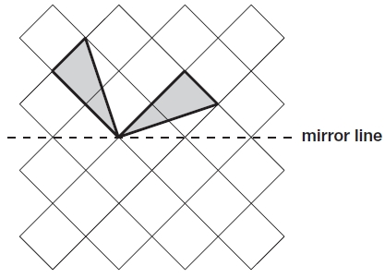
1 mark

Q4. (Y4 Standard)

Alfie places three cubes on a coordinate grid.
The base of his shape is a rectangle.
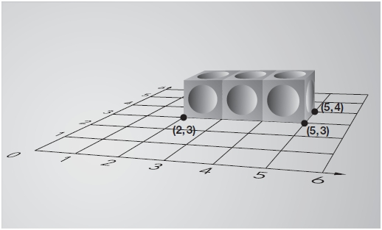
Complete this sentence:
The four vertices of the rectangle are

(2, 3), (5, 3), (5, 4) and
1 mark

Q5. (Y4 Standard)

These three square tiles have symmetrical patterns on them.
Draw the line of symmetry on each tile.
Use a ruler.
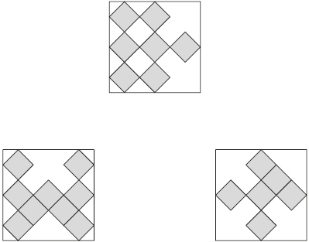
2 marks

Q6. (Y5 Standard)

Circle the pentagon with exactly four acute angles.
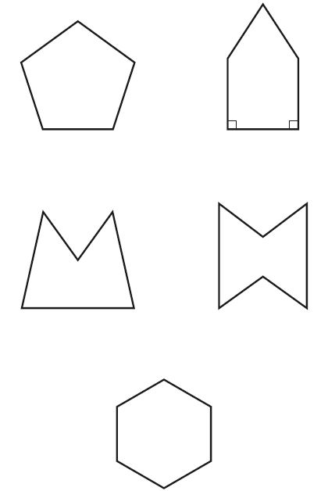
1 mark

Q7. (Y5 Standard)
Here is a drawing of a 3-D shape.
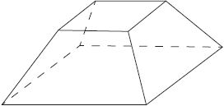
Complete the table.

Number of faces | Number of vertices | Number of edges
2 marks
Q8. (Y5 Standard)

Here are three nets of a cube.
On each net draw one more dot so that each cube will have dots on opposite faces.

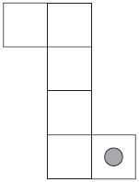
2 marks

Q9. (Y5 Standard)

Emma makes a cuboid using 12 cubes.
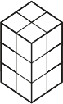
Write the letter of the cuboid that has a different volume from Emma’s cuboid.
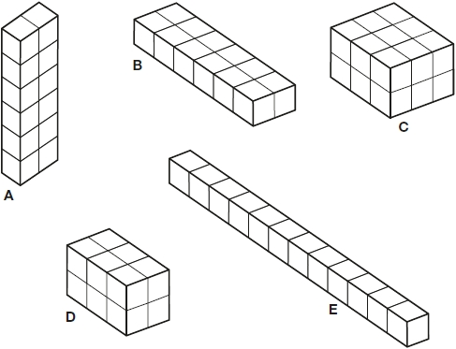
________________________
1 mark

Q10. (Y5 Standard)

In this diagram R is an equal distance from P and Q.

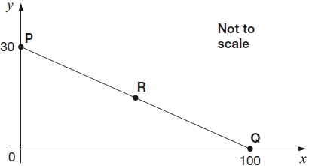
What are the coordinates of R?
1 mark
Q11. (Y6 Standard)

Layla completes one-and-a-half somersaults in a dive.
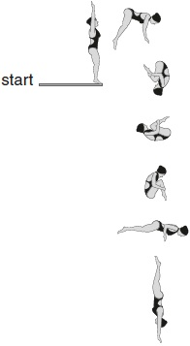
How many degrees does Layla turn through in her dive?
1 mark
Q12. (Y6 Standard)

A shaded isosceles triangle is drawn inside a rectangle.

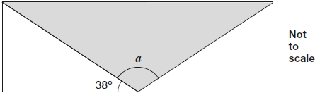
Calculate the size of angle a.

2 marks

Q13. (Y6 Standard)

Emily has 6 cubes.
She sticks them together to make this model.

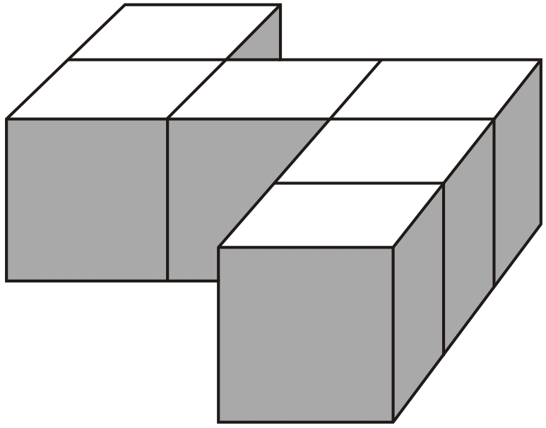
She paints the sides of the model grey all the way round.
She leaves the top and the bottom of the model white.
How many of the cubes in the model have exactly two faces painted grey?
1 mark

Q14. (Y6 Standard)

The diagram shows two identical squares.

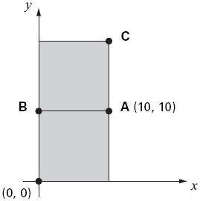
A is the point (10, 10)
What are the coordinates of B and C?
1 mark
1 mark

Q15. (Y6 Standard)

Here are diagrams of some 3-D shapes.
Tick each shape that has the same number of faces as vertices.

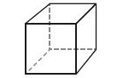 | Cube
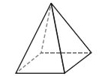 | Square-based pyramid
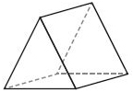 | Triangular prism
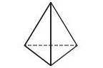 | Triangular-based pyramid
2 marks

Mark schemes
Q1.

(a) c AND e
Letters may be given in either order.
1
(b) a AND d
Letters may be given in either order.
1
[2]
Q2.

The triangle has moved |  | squares to the right
and |  | squares down.
[1]
Q3.
Diagram completed as shown:
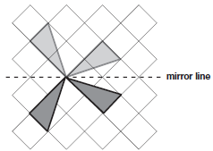
Accept slight inaccuracies in drawing.
Diagram need not be shaded.
[1]

Q4.
(2, 4)
[1]
Question Requirement Mark Additional guidance
Q5.
Award TWO marks for three lines of symmetry drawn correctly as shown:
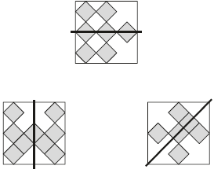
If the answer is incorrect, award ONE mark for two lines of symmetry
correctly drawn.
Accept inaccurate drawing provided the intention is clear.
Up to 2
[2]
Q6.

The correct shape circled as shown:
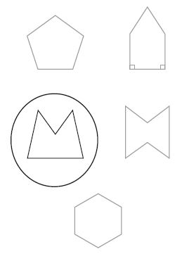
Accept alternative unambiguous positive indications, e.g. shape ticked.
[1]
Q7.
Award TWO marks for the table completed, as shown:

Number of faces | Number of vertices | Number of edges
6 | 8 | 12
Award ONE mark for two correct numbers, correctly placed.
Up to 2m
[2]
Q8.
Award TWO marks for three diagrams completed as shown:
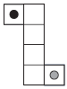
Accept alternative unambiguous indications.
If the answer is incorrect, award ONE mark for two diagrams correct.
Up to 2
U1
[2]
Q9.

C
Accept 18.
[1]
Q10.
(50, 15)
[1]
Q11.

540
[1]
Q12.
Award TWO marks for the correct answer of 104°.
If the answer is incorrect, award ONE mark for evidence of an appropriate method, e.g:
• 180 − 38 − 38 = a
Answer need not be obtained for the award of ONE mark.
Up to 2
[2]
Q13.
4
U1
[1]
Q14.
(a) (0, 10)
Coordinates must be written in the correct order.
Accept unambiguous answers written on the diagram.
1
(b) (10, 20)
If the answer for part (a) is (10, 0) AND the answer to (b) is
(20, 10), award ONE mark only, in the part (b) box.
1
[2]
Q15.

Award TWO marks for both pyramids ticked as shown:
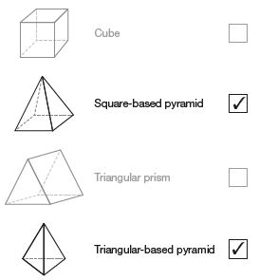
Accept alternative unambiguous positive indications, e.g. Y.
If the answer is incorrect, award ONE mark for:
• the two pyramids and not more than one incorrect shape ticked
OR
• only one correct shape ticked and no incorrect shape ticked.
Up to 2m
[2]

