Phonics/Reading
Monday | Tuesday | Wednesday | Thursday | Friday
Play a game on Phonics Play https://www.phonicsplay.co.uk/

Write a list of words containing the sound of the day.  Mrs Andrew/Lynsey group: th  Mrs Penhaligan’s group: ure  Mrs Hughes’ group: scr  Jade’s group: ay | Write a list of words containing the sound of the day.  Mrs Andrew/Lynsey group: oa  Mrs Penhaligan’s group: ear  Mrs Hughes’ group: sm  Jade’s group: ue | Write a list of words containing the sound of the day.  Mrs Andrew/Lynsey group: or  Mrs Penhaligan’s group: str  Mrs Hughes’ group: ey  Jade’s group: aw | Write a list of words containing the sound of the day.  Mrs Andrew/Lynsey group: ow  Mrs Penhaligan’s group: cl  Mrs Hughes’ group: ph  Jade’s group: ph | Write a list of words containing the sound of the day.  Mrs Andrew/Lynsey group: igh  Mrs Penhaligan’s group: dr  Mrs Hughes’ group: ay  Jade’s group: ey
Mrs Hughes and Jade’s group – include the alternative representations of the sounds if there are any – e.g. ai, ay, a_e in your lists

Choose a different way to practice your tricky words each day from the list below.

Rainbow write – choose a different colour for each word | Chalk them outside |  | Bubble write – use bubble writing |  | Write them in alphabetical order |  | Use each of your spellings in a sentence
Mrs Andrew/ Lynsey  they are her so  do |  | Mrs Penhaligan  so do some  come were |  | Mrs Hughes  want are our  today where |  | Jade  want are our  today where

Reading (at least 20 minutes a day) | Read your own book or share a story together. Every few pages look at and have a go at answering 1-3 of the vipers questions – see below.  At the end of the week write a review about your favourite book. Remember to ask for sponsorship for Read for Good!

Writing
 | Monday | Tuesday | Wednesday | Thursday | Friday
Reception | Think of someone who you are missing during the lockdown. Write them a letter and draw a picture to go with it. Have a walk to the post box, if you can, to post it.
Year 1 focus activities | Who could you send a letter to that you are unable to see at the moment? ( Grandparent, aunty, uncle, cousin…).Make a mind map or draw pictures with labels of all the things you want to tell them about. What have you been doing? How you are feeling, what you want to do when you see them next? | Start writing your letter. Don’t forget to include the date, address, and start with ‘Dear ….’ Look at the example below to help you set your letter out. Include some questions to ask the person you are writing to. | Read your letter to a grown up at home, check your spelling, full stops, capital letters, commas and question marks. You could write your finished letter up again in your BEST handwriting. | Draw a lovely cheerful picture to go with your letter. | Write the address on an envelope, put a stamp on it and post it.
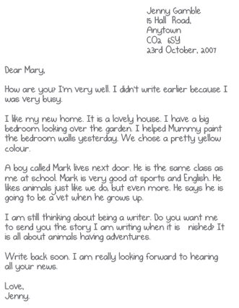
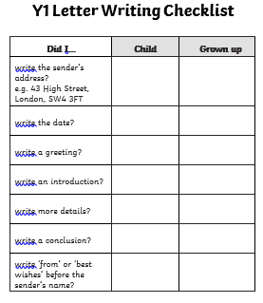

Maths
Monday | Tuesday | Wednesday | Thursday | Friday
Complete the assigned tasks on Mathletics.

Make a paper chain with the days of the week on.  I challenge you to do another with the months of the year.  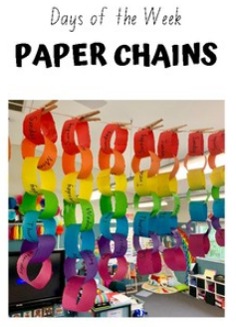 |  |  | Go on Supermovers and choose a challenge https://www.bbc.co.uk/teach/supermovers/

