Wider Curriculum
Below is a list of suggested activities – you may have your own ideas and projects that you want to try.

Find the 12 wild flowers shown at this website http://www.wildlifeinsight.com/3544/wild-flowers-in-spring-hedgerows/  I have found 10 so far! | 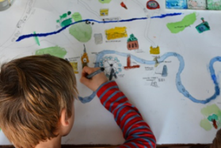  Draw a map of a walk you have taken in your local area. | Find a recipe for wild garlic pesto. With a grown up, pick some wild garlic leaves and make the recipe. |  | Have a go at one of the activities from the Code Fluency attachment.
Watch this Deadly 60 Rhino Special  https://www.bbc.co.uk/iplayer/episode/m000fkww/deadly-60-series-4-1-rhino-rescue-special | Email Mr Hannah @ head@duloeprimary.co.uk and let me know what you have been up to. | Make sure you enter the Art competition for a new mosaic sign outside the school. |  | Design the ultimate secret base. What weapons and inventions would you have?
Tidy your bedroom without your parent/carer asking as see how impressed they are! | Joe Wickes is running online PE sessions daily at 9am: https://www.youtube.com/channel/UCAxW1XT0iEJo0TYlRfn6rYQ |  | Take a photo of a landscape and email it to Mr Hannah @ head@duloeprimary.co.uk d let me know what you have been up to.

