Q1.
Which sentence is the most formal?
Tick one.
The way they played was terrible, wasn’t it?
I wish they’d put a little more effort in today!
If only they’d tried a bit harder, they would’ve won.
The team were defeated due to mistakes that they made.
1 mark
Q2.
Circle the most formal option in each box below to complete the invitation.

We would like to invite you to a | catch-up  celebration  get-together

to mark this | fab  really cool  momentous | occasion.

It will | start up  commence  kick off | at 5pm.
1 mark

Q3.

There is an error in the sentence below. Write the correction in the box.
The confused cyclist weren’t sure where to go.

1 mark
Q4.
Circle the correct word in each box to complete the sentences in Standard English.

Pass me | them  those | cartons, please.

You sang that song very | good.  well.

We always | did  done | our homework on time.
1 mark

Q5.
Which sentence is written in Standard English?

Tick one.
Two sports teams come to our school yesterday.
My friend was tidying the classroom.
Today the children done their school play.
The teachers was going to send a letter next week.
1 mark

Mark schemes
Q1.
Award 1 mark for the correct box ticked.
The team were defeated due to mistakes that they made
1 mark
Q2.
Award 1 mark for the correct word encircled in each box.
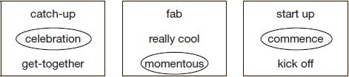
1 mark
Q3.

wasn’t OR was not OR cyclists
Do not accept changes of tense, eg:
• isn’t
1 mark
Q4.
Award 1 mark for the correct word circled in each box.
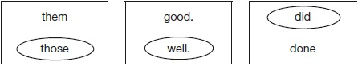
1 mark
Q5.
My friend was tidying the classroom.
1 mark

