Wider Curriculum
Below is a list of suggested activities – you may have your own ideas and projects that you want to try.

Lego bedroom / house maps: Lego bricks make great representations of features on a map, from buildings, to individual pieces of furniture in a room plan. Try making a map of a room in your house using lego and then drawing a map of the model that you have made!  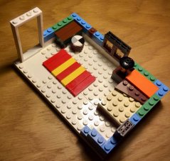 | Add some sound effects to a nursery rhyme that you know. You could try and use different ‘instruments’ which you can find in your house (saucepans, boxes, whistles, or your voice).  Here are some ideas for nursery rhymes:  https://www.bbc.co.uk/teach/school-radio/nursery-rhymes-a-to-z-index/z4ddgwx | Look at paintings by an artist called Monet. He loved painting pictures with flowers. Try and recreate one of his paintings.  ( There are some ideas below). |  | This Friday is VE day. Try and find out some information about this day. What does VE stand for? Why do we celebrate it? You could watch Newsround today as I am sure they will talk about it. (9.15 am, 12.15 pm, 4pm CBBC channel)  You could find out if any of your family members took part in World War 2.
 | Try and make your own bioplastic. There is a recipe attached. | Find out about the explorer Neil Armstrong. You could watch this clip:  https://www.bbc.co.uk/teach/class-clips-video/ks2-neil-armstrong/zr9tjhv  Imagine you are Neil Armstrong – write a diary entry of the day you arrived on the moon.
Play Boccia – read the rules for the Paralympic sport of boccia and see if you can adapt and play a game inside or outside. | How many star jumps, burpees, skips, squats can you do in 1 minute? Can you beat your brother/sister/ mum/ dad? |  | Set up a science experiment to find out if you wrap ice up in different materials it will melt faster or slower? You could use anything you have at home ( tin foil, cling film, cotton tea towel, a woolly hat etc) Make a prediction and see if you are right!

