Art Competition
For home learning this week, we would like as many children as possible to join in with our art competition. Our beautiful mosaic sign, outside the school, is beginning to look a little tired, with some of the mosaics falling off. We are running a competition for a new mosaic design to replace this one (although we will repair the existing one and relocate it). We are aiming to make the mosaic with the children on the first day back after lockdown.
We are very lucky that the Bishop of Truro, the RT Revd Philip Mountstephen, has agreed to judge our competition.
Designs can include anything you like and can be any shape. Children may want to include our school vision: ‘An adventure for the mind and a home for the heart for all God’s children.’ Our values: Creativity, Compassion, Friendship, Perseverance and Respect. Or our school parable: The Lost Sheep. However, designs may consist of anything the children would like.
Designs do not have to be created in mosaic tiles, our resident artist, Mrs Dunn, will rework the winning entry into a mosaic.
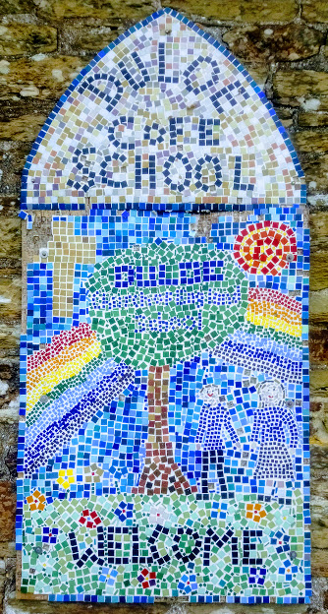
To submit your entry, children could take a photo of their design and email it to their class teacher or post it through the school letterbox while out for their daily exercise. Computer generated designs will also be welcomed.
Closing date for entries is 10th May.
Good luck and we look forward to seeing your entries.

