Phonics/Reading
Monday | Tuesday | Wednesday | Thursday | Friday
Continue to access Letters and Sounds, phonics play and teach your monster to read – along with any apps and websites that you have found to be good for phonics.  Letters and sounds https://www.youtube.com/channel/UCP_FbjYUP_UtldV2K_-niWw/channels?view_as=public  Phonics play https://new.phonicsplay.co.uk/  Teach your monster https://teachyourmonstertoread.com |  |  |  | Bank holiday
Write a list of words containing the sound of the day.  Mrs Adrew/Lynsey group: air  Mrs Penhaligan’s group: oi  Mrs Hughes’ group: oe  Jade’s group: au | Write a list of words containing the sound of the day.  Mrs Adrew/Lynsey group: y  Mrs Penhaligan’s group: air  Mrs Hughes’ group: aw  Jade’s group: nch | Write a list of words containing the sound of the day.  Mrs Adrew/Lynsey group: j  Mrs Penhaligan’s group: gr  Mrs Hughes’ group: wh  Jade’s group: shr | Write a list of words containing the sound of the day.  Mrs Adrew/Lynsey group: ure  Mrs Penhaligan’s group: sl  Mrs Hughes’ group: au  Jade’s group: thr

Choose a different way to practice your tricky words each day from the list below.

Draw a big flower and write each of your spellings on a petal. | Make your words with Lego. |  | Make your words with sticks or spaghetti. |  | Draw a different shape for each and then write your spelling word inside the shape. |  | Use your words to make a wordsearch.
Mrs Andrew/ Lynsey  a do to today I |  | Mrs Penhaligan  ask are our today  want |  | Mrs Hughes  were says because  only both |  | Jade  were says because  only both

Reading (at least 20 minutes a day) | Read your own book or share a story together. Every few pages look at and have a go at answering 1-3 of the vipers questions – see below.  Can you write speech bubbles for some of the characters in your book? What do you think they will say?

Writing
 | Monday | Tuesday | Wednesday | Thursday | Friday
 | Share the Story of Mavis the Magical Cat https://soundcloud.com/talkforwriting/mavis |  |  |  | Bank holiday
Reception | Draw pictures of the characters in the story. What do you think they look like? Can you write their names? | Pretend to be one of the characters in the story. What would the character be doing? What might they say? What would their face look like? | Find out what the words golden, speckled and magical mean. Can you draw a picture of something that is all of those words? | Choose your favourite toy and take them on a magical adventure. Take some photos or draw pictures to show where your toy has been.
Year 1 | Draw and label the characters and objects that are in the story. Talk about their size, colour | Find out what the words in the list mean and draw a picture to illustrate the meaning.  Magical  Speckled  Soil  Golden  Whiskers | Can you draw a story map showing Mavis’s adventure? Add in words to help you re-tell the story to an adult. | Take your own toy on an adventure – photograph or draw where your toy goes. You will need this next week!
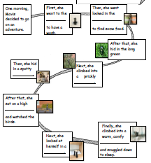
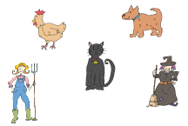

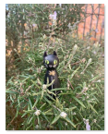
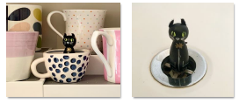

Maths
Monday | Tuesday | Wednesday | Thursday | Friday
Follow the link to White Rose Maths and you will find a series of lessons, with short videos and a worksheet to go alongside. Work through in chronological order. The answers are also available on the website.

Reception - https://whiterosemaths.com/homelearning/early-years/

Year 1 - https://whiterosemaths.com/homelearning/year-1/

Don’t forget to check out your new tasks on Mathletics too.

