Phonics/Reading
Monday |  | Tuesday |  | Wednesday |  | Thursday |  | Friday
Continue to access Letters and Sounds, phonics play and teach your monster to read – along with any apps and websites that you have found to be good for phonics.
Letters and sounds https://www.youtube.com/channel/UCP_FbjYUP_UtldV2K_-niWw/channels?view_as=public
Phonics play https://new.phonicsplay.co.uk/
Teach your monster https://teachyourmonstertoread.com
Write a list of words containing the sound of the day.  Mrs Adrew/Lynsey group: zz  Mrs Penhaligan’s group: pl  Mrs Hughes’ group: shr  Jade’s group: mp | Write a list of words containing the sound of the day.  Mrs Adrew/Lynsey group: v  Mrs Penhaligan’s group: gl  Mrs Hughes’ group: thr  Jade’s group: nk |  | Write a list of words containing the sound of the day.  Mrs Adrew/Lynsey group: w  Mrs Penhaligan’s group: tw  Mrs Hughes’ group: str  Jade’s group: nt |  | Write a list of words containing the sound of the day.  Mrs Adrew/Lynsey group: fl  Mrs Penhaligan’s group: sc  Mrs Hughes’ group: nd  Jade’s group: xt |  | Write a list of words containing the sound of the day.  Mrs Adrew/Lynsey group: gl  Mrs Penhaligan’s group: sn  Mrs Hughes’ group: ft  Jade’s group: lk

Choose a different way to practice your tricky words each day by using a dice to see what you need to do.
Write each word 3 times. | Write each word in rainbow colours. |  | Write the words all in CAPITALS. | Write the words in silly letters. | Write each word and then a word that rhymes. |  | Write a sentence for each word.
Mrs Andrew/ Lynsey  ask is his has  was |  | Mrs Penhaligan  of said says were  your |  | Mrs Hughes  out about mouth  sound cloud |  | Jade  out about mouth  sound cloud

Reading (at least 20 minutes a day) | Read your own book or share a story together. Every few pages look at and have a go at answering 1-3 of the vipers questions – see below.  Draw a picture of the setting of your book. Write some descriptive words about the setting.

Writing
 | Monday | Tuesday | Wednesday | Thursday | Friday
 | We are continuing to work on the Story of Mavis the Magical Cat https://soundcloud.com/talkforwriting/mavis
Reception | Attach your photos from last week, or draw pictures, to a story map and tell your story to a grown up of the adventure your toy went on. | Make a book of your toys adventure. | Continue your book. Remember to use your phonics to sound out the tricky words. | Share the poem ‘Happy poem’. Can you clap along with the rhythm?  Draw and label some of the objects that were in the poem. | Can you make an elastic band paintbrush and paint a colourful rainbow like in the story?
Year 1 | Attach your photos from last wee, or draw pictures, to a story map and tell your story to a grown up of the adventure your toy went on. Add words along to remind you of places and important parts. | Begin to write your own magical adventure story. | Read your story through, edit and then continue to write until you get to the end of your story map. | Share the poem ‘Happy poem’. Can you clap along with the rhythm?  For each line in the poem can you add in an adjective to make it even more descriptive?  Happy as a colourful rainbow  Happy as a buzzing bee | Make up your own ‘Happy poem’ using the same rhythm. Using adjectives to add description.  Happy as a sleeping bear  Happy as a crunchy apple
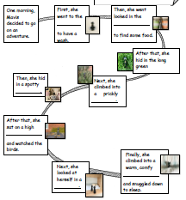

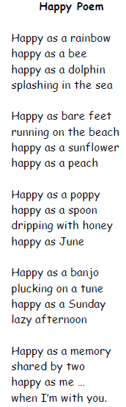

Maths
Monday | Tuesday | Wednesday | Thursday | Friday
This week the video links will be available on White Rose but not the worksheets. We are working on this.
Reception - https://whiterosemaths.com/homelearning/early-years/
Year 1 - https://whiterosemaths.com/homelearning/year-1/

Please log in to Mathletics and complete your tasks on there.

BBC Bitesize home learning also have some great activities and videos to get you thinking.

Remember that so much maths happens everyday – weighing ingredients, ordering/sorting toys, jumping on a trampoline whilst counting in 2’s, 5’s, 10’s, counting back before firing a nerf gun, drawing pictures with different shapes, telling the time, counting out money for a teddy toy shop…

