Wider Curriculum
This week all of our wider curriculum ideas are about the seaside. I am missing the sea very much so I would love to see some of your creations.
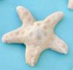  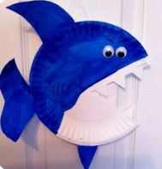  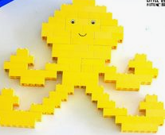  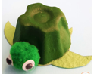  Make your favourite sea creature any way you like – maybe junk model, material, Lego, natural objects,…  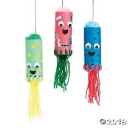 |  |  | Create a fact file about your sea creature. Where can you find it? What does it eat? Describe what it looks like. |  |  | 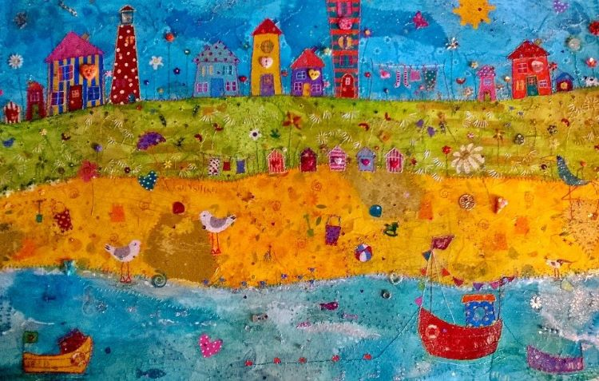  Can you create a seaside picture like this one by Kate Durdy?
Find out about seaside holidays 100 years ago. What did people wear?  How did people get to the seaside?  What did you eat?  What did you do when you were there? | Make a treasure map. Include clues and directions for finding the treasure. |  |  | 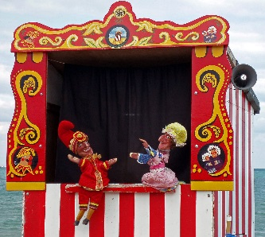  Make your own Punch and Judy puppets and put on a show. |  |  | Explore objects you have at home. Which ones float and sink? Record what you find out. |  | Using one of the materials that you know float, design and build a boat.
Plan and make a picnic for a trip to the seaside. Enjoy your picnic with your family. |  | Find out who Grace Darling was and why she is so important in history. |  |  | Design a postcard and send it to someone you are missing. |  |  | Explore the history behind the RNLI. Look on the website and complete some of the activities. Can you learn what the different flags mean? Draw them and teach someone at home.  https://rnli.org/youth-education/education-resources

