Wider Curriculum
Below is a list of suggested activities – you may have your own ideas and projects that you want to try.
Give a used plastic bottle a new lease of life by turning it into a plant pot. Don’t forget to add drainage holes in the bottles.  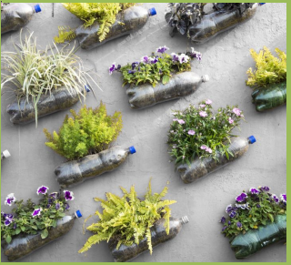  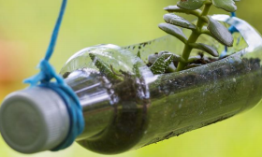 | Sprouting seeds: If you have access to any of the following, they can be germinated by popping them in a sealed jam jar and sprinkling water on them. You can eat the sprouts as long as you have used clean water and rinsed them well before adding to sandwiches or salads. You need to use the dry version - not tinned!  * chickpeas * most beans (don’t use kidney beans for eating raw) * alfafa * peas * fenugreek * sunflower seeds (with shells) | Find out what we mean by solar energy. Watch this video to learn that all our energy comes first from the sun. What are some of the ways that we can convert the sun’s energy into energy we can use in our homes? https://www.youtube.com/watch?v=inPtRWtvDaM  Make a solar powered oven: On a sunny day, you should be able to use it to melt cheese, chocolate or marshmallows.  (See instructions below.) |  | Make a bug hotel. You can encourage many insects into your garden by creating a habitat for them to live in. The hotel can be as big as the space you have allows, but it’s possible to make a small one inside a flower pot or wooden box. As long as the container is reasonably weather proof, it’s fine to use whatever you have. The bugs need little crevices to live in. You can make these by collecting twigs and sticks, straws, leaves and grasses or little pebbles and bits of moss. If you don’t have access to these materials outdoors, you can make little rolls of paper to poke in, or peel bits of corrugated cardboard to reveal the little gaps inside.
Donkey tails: Use a strip of material or a sock to make your ‘donkey tail’ by poking it into your waistband behind your back. Everyone tries to capture each others’ tail, whilst keeping their own. Make the game fairer by giving the slowest member of the family a shorter tail. | Giuseppe Arcimboldo was an artist who liked to arrange vegetables into faces! Have a go at using fruit and vegetables to create a picture on a sheet. (see below)  Or you could use this website to create a digital version:  http://www.middlestreet.org/archim/archimframe.htm |  | Follow this link to find out about the explorer Christopher Columbus.  https://www.bbc.co.uk/teach/class-clips-video/ks2-christopher-columbus/z7j3hbk  If you have a globe or map, try and find where he thought he was going and where he actually ended up.
Giuseppe Arcimboldo’s art: A child’s version:

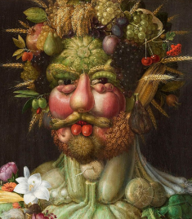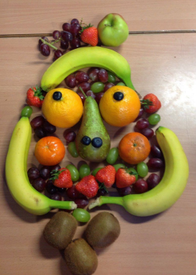

Make your own Solar Oven:
You will need: • A pizza box • Some aluminium foil • Sticky tape • Scissors • A pen or pencil • A piece of wire (you can prop open the lid with a pencil if you don’t have wire) • A sheet of plastic film such as a file divider, some acetate or some food wrap.
First, you will need to cut a flap out from the lid of the pizza box.
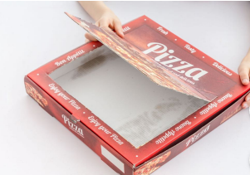
Next, stick your plastic over the hole you have just cut out.
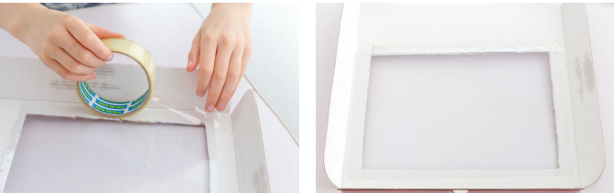

Cover the flap with the aluminium foil on the inside, to reflect heat on to your food when it is inside the ‘oven’. Line the box with more foil. Keep the shiny side of the foil outwards.
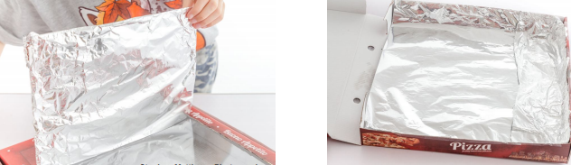

Hold the flap of your oven open with a piece of wire, folded and taped into place. Adjusting the length of the wire will allow you to angle the flap so that the sun can hit the food inside.
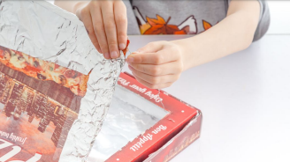

Place your completed oven in a sunny place. You can choose which sort of food to try melting. It might take a while, but keep checking!

