Space Tourism

In 1969, a man walked on the Moon for the first time. After this, many
people thought that space travel would be available by the year 2000
and that we would all be space tourists. However, here we are in 2015
and space tourism is still an impossible dream for most of us. It is a
reality for only a very few, very rich, people.
How would you get to your space hotel?
In the future there may be hotels in space for all the tourists. It wouldn’t take
long for the space shuttle to get out of the Earth’s atmosphere. Then, without
Earth’ gravity, you would become weightless. Arrival at the hotel would be
like an aeroplane parking at an airport but you would leave the cabin
floating along the access tube, holding on to a cable.
Fact: The Russian Space Agency  offers flights on board a spacecraft to  the International Space Station (ISS),  where people can stay. The ISS was  built in 1998 and is so big that it can  be seen from Earth. Tickets to the ISS  are very limited. |  | What would a space  holiday be like?  Once in the hotel, you could  admire the unique views of  Earth and space and enjoy the  endless entertainment of being  weightless – and there would  always be the possibility of a  space-walk.
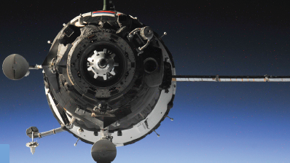 |  |  | Fact: The first  tourist in pace  was Dennis Tito  in 2001. His trip  cost him around  £14 million.

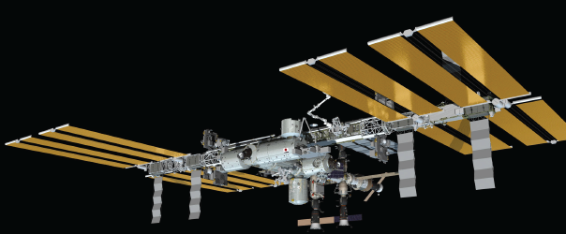
Who has already had a holiday in space?
In 2006, Anousheh Ansari became the first female space tourist when she made the trip from Russia to the International Space Station (ISS). Anousheh stayed on the ISS for eight days and kept a blog (an online diary). Parts of her blog are shown here.
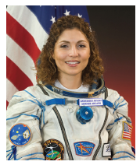 | Anousheh’s Space Blog  September 25th  Everyone wants to know: how do you take a shower in space? How do you brush your teeth? Well my friends, I must admit keeping clean in space is not easy! There is no shower with running water. Water does not ‘flow’ here, it ‘floats’ – which makes it a challenging act to clean yourself. There are wet towels, wet wipes and dry towels that are used. Now brushing your teeth in space is another joy. You cannot rinse your mouth and spit after brushing, so you end up rinsing and swallowing. Astronauts call it the ‘fresh mint effect’.  September 27th  Being weightless has some wonderful advantages. You can lift a really heavy object with one hand and move it around with one finger. You can fly and float around instead of walking. You can do somersaults at any age. Everything is effortless. If you want to move forward, you slightly touch a wall with one finger and you start moving in the opposite direction. If you have left your book at the other side of the module, no problem – you ask someone close to it to send it to you. That means they pick it up and very gently push it towards you, and here it is – your book flying to you all the way from the other side.

Shooting stars
Be a space tourist at home
While space travel is an impossibility for most of us, you can still be a tourist
from here on Earth by spotting shooting stars!
Space is full of huge and tiny pieces of rock, which burn up in a flash when they
enter the Earth’s atmosphere. The flash of burning rock is called a meteor. As it
moves through the night sky, you can see the trail it leaves behind – which is
what we know as a shooting star.
On most clear nights, you should be able to see up to 10 meteors every hour.
But, at certain times of the year, many more meteors appear than usual. When
this happens, we call it a meteor shower.
Star spotters' guide to  seeing shooting stars  1. Find out when a meteor shower is  due and arrange to go star spotting  with an adult (they don’t have to be  an expert!).  2. Wear warm clothes and equip  yourself with a blanket, a pillow and  a torch.  3. You do NOT need a telescope or  binoculars.  4. Go outside and find somewhere that  is far away from town lights.  5. When you have found your spot, lie  down on your blanket, switch OFF  your torch and stare up at the sky.  6. Allow some minutes to pass. The  longer you look, the more stars you  will see as your eyes get used to the  darkness.  7. Wait for the shooting stars to appear! | 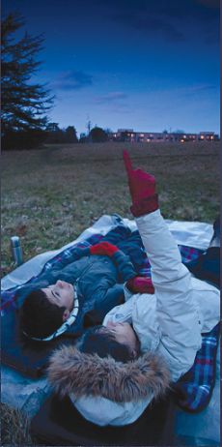

1. Look at the introduction.
Why is space tourism impossible for most people?
______________________________________________________________
______________________________________________________________
1 mark
2. How would you get from the spacecraft to the space hotel?
______________________________________________________________
______________________________________________________________
1 mark
3. According to the text, what could you do on your space holiday?
Give two examples:
1. ____________________________________________________________
2. ____________________________________________________________
2 marks
4. How much did the first space tourist pay to go into space?
______________________________________________________________
1 mark
5. How can you tell that the International Space Station is very large?
______________________________________________________________
______________________________________________________________
1 mark
6. How did Anousheh’s trip into space make history?
______________________________________________________________
______________________________________________________________
1 mark

7. Look at the text box Who has already had a holiday in space?
Complete the table about Anousheh’s trip into space.

Where did she start her trip?
Where did she stay in space?
How long did she stay in space?
2 marks
8. Look at Anousheh’s blog entry for September 25th.
Find and copy a group of words that shows that Anousheh wrote her
blog for others to read.
______________________________________________________________
______________________________________________________________
1 mark
9. Look at Anousheh’s blog entry for September 27th.
Explain how Anousheh felt about being in space that day.
______________________________________________________________
______________________________________________________________
______________________________________________________________
______________________________________________________________
2 marks

10. Match the events below to the year in which they happened.
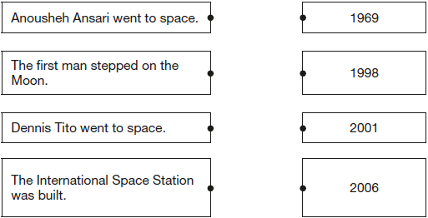
1 mark

11. Using information from the text, tick one box in each row to show whether each statement is a fact or an opinion.

 | Fact | Opinion
Anousheh Ansari kept an online diary.
Brushing your teeth in space is a joy.
Being weightless is endlessly entertaining.
Tourists can stay on the International
Space Station.
1 mark
12. …in a flash...
What does this tell you about the burning of rocks in space?
______________________________________________________________
______________________________________________________________
1 mark

13. Find out when a meteor shower is due and arrange to go star spotting
with an adult…
In this sentence, the word arrange is closest in meaning to…

Tick one.
set out.
meet.
pack up.
plan.
1 mark
14. How does the information make it sound easy to be a star spotter?
Give two ways.
1. ____________________________________________________________
______________________________________________________________
2. ____________________________________________________________
______________________________________________________________
2 marks
15. Tick true or false in the following table to show what you should do when
spotting shooting stars.

 | True | False
Take warm clothes, a blanket, a pillow and a torch.
Stay close to town.
Point your torch up to the sky.
You must have binoculars.
1 mark

Mark schemes
Q2.

1. Award 1 mark for explaining that it is impossible for most people because it costs too much, e.g.
• most people can’t afford it
• it is too expensive.
1 mark
2. Award 1 mark for answers that refer to floating down the tube (holding the cable).
1 mark
3. Award 1 mark for identifying any of the following activities, up to a maximum of
2 marks:
1. look at Earth or space / admire the view, e.g.
• admire unique views of Earth
• look at the outside of earth
• look down at Earth.
2. experience weightlessness / activities associated with floating, e.g.
• enjoy being weightless
• enjoy the endless entertainment of being weightless.
3. space-walk, e.g.
• do a space walk.
Do not accept plausible experiences that are not derived from the text or are unconnected with space travel, e.g.
• take photos of the moon / see what the Moon is made from
• I’d write a blog
• stay in a hotel.
Up to 2 marks
4. Award 1 mark for (around £)14 million / (£)14m.
1 mark
5. Award 1 mark for answers referring to the fact that it can be seen from Earth, e.g.
• You can see it from / on Earth.
1 mark
6. Award 1 mark for answers recognising that she was the first female space tourist.
• she was the first lady to have a holiday in space
• she was the first female tourist in space.
Do not accept answers that say she was the first female (into space).
1 mark
7. Award 2 marks for all three correct.
Award 1 mark for two correct.

Where did she start her trip? | • Russia  Do not accept Russian ISS or Earth
Where did she stay in space? | • space station / ISS
How long did she stay in  space? | • 8 days  Do not accept 8
Up to 2 marks
8. Award 1 mark for either of the following:
1. (Well) my friends
2. Everyone wants to know.
Do not accept longer quotations from the text.
1 mark
9. Award 2 marks for answers that contain both an appropriate reference to Anousheh’s positive attitude, inferred from the text, and development in the form of a relevant quote / example(s) of activities she did in space, e.g.
• you can tell that she liked space because of all the fun things she wrote like floating about without any effort and lifting heavy things
[positive attitude + examples of activities]
• she enjoyed it because of all the wonderful advantages she kept on describing [positive attitude + quote]
• she felt wonderful being able to do somersaults and flying around
[positive attitude + examples of activities].
Award 1 mark for identifying Anousheh’s positive attitude inferred from the text, e.g.
• she loved it / she felt it was wonderful.
Also accept for 1 mark the following quotations (as they convey positive emotion), e.g.
• she said being weightless had some wonderful advantages
• everything is effortless.
Do not accept emotions that are not supported by the text, e.g. pride.
Up to 2 marks
10. Award 1 mark for all four pairs matched correctly.
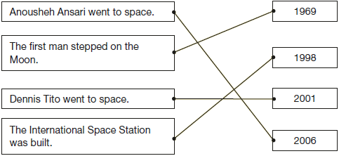
1 mark
11. Award 1 mark for all four correct.

 | Fact | Opinion
Anousheh Ansari kept an online diary.
Brushing your teeth in space is a joy.
Being weightless is endlessly entertaining.
Tourists can stay on the International
Space Station.
1 mark
12. Award 1 mark for either acceptable point:
1. the rock burns very quickly, e.g.• they burn quickly / suddenly / instantly
• it happens fast.
2. the rock burns brightly, e.g.
• when the rock burns you get a dazzling light.
Do not accept reference to speed of travel, e.g.
• they go / fly / travel very quickly.
1 mark
13. Award 1 mark for the correct option ticked.
set out.
meet.
pack up.
plan.
1 mark
14. Award 1 mark for reference to any of the following acceptable points, up to a maximum of 2 marks:
1. accessible location, e.g.
• You don’t have to travel far to do it
• You don’t have to be in space (to see them)
• You don’t have to leave Earth.
2. you do not need specialist equipment, e.g.
• You can do it with things you’ll have in the house
• You don’t need a telescope or binoculars
• You don’t need any expensive equipment
• It sounds easy because all you need is a nice spot, a blanket, pillow and torch.
3. you don’t need an expert to show you how to do it, e.g.
• You just need to go with an adult, they don’t need to know anything about space.
Do not accept answers that are focussed on the structure of page 6, e.g.
• the instructions are laid out clearly.
2 marks
15. Award 1 mark for all four correct.

 | True | False
Take warm clothes, a blanket, a pillow and a torch.
Stay close to town.
Point your torch up to the sky.
You must have binoculars.
1 mark

