Q1.

What does the prefix ‘bi’ mean in this group of words?
bilingual biannual bisect binoculars

Tick one.
two or twice
outside or external
under or below
through or across
1 mark
Q2.

Circle two suffixes that can be added to the word below to make new words.
enjoy
ful ment able less ness
1 mark
Q3.

Draw a line to match each word with its synonym.

Word |  | Synonym
vast |  | dull
swift |  | busy
drab |  | huge
bustling |  | fast
1 mark
Q4.

Add a prefix to the beginning of each word to form its antonym.
______________agree
______________legal
______________regular
1 mark
Q5.

Replace the underlined word with a word that has a similar meaning.
Write the new word in the box.
When they returned, all the others had disappeared.

1 mark

Mark schemes
Q1.

two or twice
1 mark
Q2.

Award 1 mark for both suffixes encircled.
ful less ness
1 mark
Q3.

Award 1 mark for all four correct.
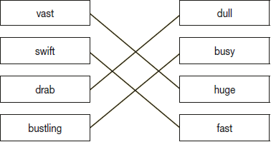
1 mark
Q4.

Award 1 mark for all three correct.
disagree
illegal
irregular
1 mark
Q5.

Award 1 mark for a suitable past participle synonym, eg:
• vanished / gone / left
1 mark

