Wider Curriculum
Below is a list of suggested activities – you may have your own ideas and projects that you want to try.
Make your own playdough.  - 1 cup flour  - 2 tsp cream of tartar  - 1/2 cup salt  - 1 tbsp cooking oil  - 1 cup water  - food colouring  In a large bowl, combine all of your dry ingredients (flour, salt, cream of tartar) and mix well.  Mix food colouring with your water first. Then add the vegetable oil and water with food colouring to a large pot. Mix together.  Add the dry ingredients to your pot and mix well.  Cook over low to medium heat until the dough starts to form and becomes dry.  Once it starts to form a ball together and looks fully cooked, take off the heat. Let the dough cool first before touching.  Once cool, knead the dough for 5 minutes to make the dough soft. | When you are out for a walk, collect some different leaves from trees. Find out the names of the trees and when you get home try sketching the leaves as carefully as you can. Look at the veins and the shapes of the leaves.  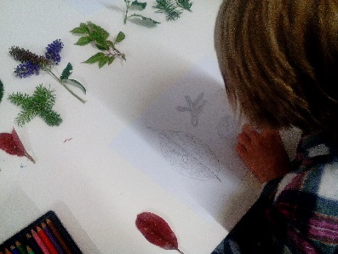 | Can you make a musical instrument using things you have at home? ( A few ideas below). How will it make sound? Do you hit it, blow into it, pluck it….?  When you have made it, try playing it in different ways: loudly, softly, quickly, slowly, high note, low notes. |  | With a grown up prepare a picnic and then go somewhere lovely to eat it with your family. You could make it all yourself ( bake your own bread, pasties, cakes etc,) or just make a few sandwiches and fill up a bottle of water. Enjoy being out in the fresh air eating and drinking!
Skipping challenge. How many skips can you do in 2 minutes? Keep a record and see if you can beat your score each day. | Use plasticine, play dough or kitchen foil to design a boat which will take the maximum number of ‘passengers’. Investigate different shapes to find out which works best. |  | https://www.bbc.co.uk/teach/class-clips-video/ks2-ibn-battuta/zmqgnrd  Find out about the journeys of Ibn Battuta. Try and find some of the countries he visited on a map.

