Phonics/Reading
Monday |  | Tuesday |  | Wednesday |  | Thursday |  | Friday
Continue to access Letters and Sounds, phonics play and teach your monster to read – along with any apps and websites that you have found to be good for phonics.
Letters and sounds https://www.youtube.com/channel/UCP_FbjYUP_UtldV2K_-niWw/channels?view_as=public
Phonics play https://new.phonicsplay.co.uk/
Teach your monster https://teachyourmonstertoread.com
Write a list of words containing the sound of the day.  Mrs Adrew/Lynsey group: ck  Mrs Penhaligan’s group: scr  Mrs Hughes’ group: a_e | Write a list of words containing the sound of the day.  Mrs Adrew/Lynsey group: ff  Mrs Penhaligan’s group: shr  Mrs Hughes’ group: e_e |  | Write a list of words containing the sound of the day.  Mrs Adrew/Lynsey group: ss  Mrs Penhaligan’s group: thr  Mrs Hughes’ group: i_e |  | Write a list of words containing the sound of the day.  Mrs Adrew/Lynsey group: ll  Mrs Penhaligan’s group: br  Mrs Hughes’ group: o_e |  | Write a list of words containing the sound of the day.  Mrs Adrew/Lynsey group: pl  Mrs Penhaligan’s group: nch  Mrs Hughes’ group: u-e

Choose a different way to practice your tricky words each day by using a dice to see what you need to do.
Write each word 3 times. | Write each word in rainbow colours. | Write the words all in CAPITALS. | Write the words in silly letters. | Write each word and then a word that rhymes. | Write a sentence for each word.
Mrs Andrew/ Lynsey  want said the they I |  | Mrs Penhaligan  come some once school  friend |  | Mrs Hughes  find kind mind behind  child wild

Reading (at least 20 minutes a day) | Read your own book or share a story together. Every few pages look at and have a go at answering 1-3 of the vipers questions – see below.  Create a wanted poster for the main character in your book.

Writing
 | Monday | Tuesday | Wednesday | Thursday | Friday
 | This week we are going to start to explore some different traditional tales – starting with The Three Little Pigs.
Reception | Share the story together. If you don’t have a copy then there are many different versions online. Discuss what happens. | Draw a story map. | Make puppets for each of the characters and re-tell the story. | Draw a picture of your favourite character. How could you describe him to someone else? Is he kind, friendly, mean? | Can you change the ending? Use your puppets to tell the story but have a different end for the wolf.
Year 1 | As above then write a review of the version you shared. What did/didn’t you like? How many stars will you give it? Would you recommend? | Draw a story map showing the key points of the story. | Make puppets to retell the story. Can you use different voices for the characters? | Choose 1 character and create a character profile. Which adjectives would you use to describe your character? What is their personality like? | Create a new ending for the story. Make a flap to go over your story map to show the new ending. If you would like to write the story with your new ending or use your puppets to tell your version of the story.
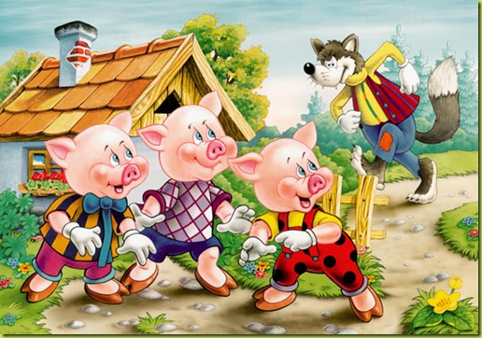

Maths
Monday | Tuesday | Wednesday |  | Thursday |  | Friday
Please access your year group videos on White Rose Home Learning. Worksheets will be sent.
Reception - https://whiterosemaths.com/homelearning/early-years/
Year 1 - https://whiterosemaths.com/homelearning/year-1/

Please log in to Mathletics and complete your tasks on there.

BBC Bitesize home learning also have some great activities and videos to get you thinking.

Can you make and play your own version of snakes and ladders? |  |  | Design a play a game where you can score points; skittles, numbered yoghurt pots to throw a bottle top into, targets… |  | Make a shop. Write price labels for you items and sort out the change your customers need.

