Wider Curriculum
This week most of our wider curriculum ideas are linked to the story of The Three Little Pigs.
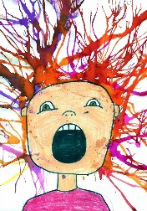  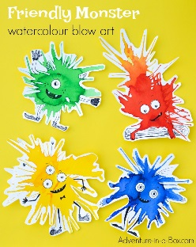  Can you huff and puff like the big bad wolf and create some blow art pictures? |  |  | Investigate materials – choose 3 different materials (paper, sticks, stones, bark, dry spaghetti, yoghurt pots…) to make 3 homes – can you huff and puff and blow any down?
Follow the step by step instructions to draw a pig. Then use shading and maybe colour mixing to colour in your pig.  There are many different step by step guides on YouTube. Choose the type of pig you would like to have a go at. |  | 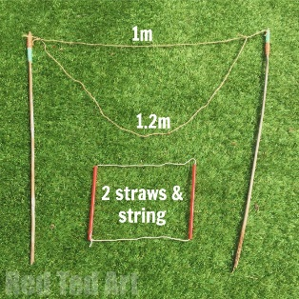  Get the bubble out or make some mixture. Try out making different bubble wands. Can you make any giant bubbles by huffing and puffing?  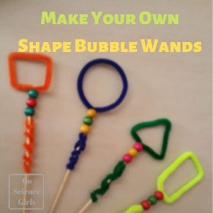 |  |  | 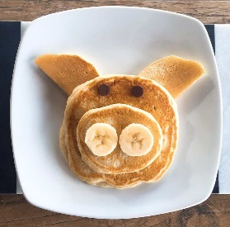  Have a go at making pig pancakes. Which fruit will you use for the features?
Get your bodies moving and have a go at Cosmic Yoga on YouTube.  https://www.cosmickids.com/ They offer a free 2 week trial but there are also many clips on YouTube. | Share the Bible story of The Good Samaritan.  https://www.bbc.co.uk/bitesize/clips/zcyr87h What could the wolf have done differently in the story to be a good Samaritan? |  |  | Draw a map to show the route the wolf took to get to the pigs’ houses. |  | Write a letter from the wolf to the pigs. What might he say? Will he apologise?

