Wider Curriculum
Below is a list of suggested activities – you may have your own ideas and projects that you want to try.

Learn a magic trick and teach it to someone else! | Find out how to say hello in a different language to use for the register when we return. Can you learn numbers to 10 as well? | Collect dandelions and make dandelion fritters or tea, even better if you can do it on a campfire. |  | You will have some activities to complete on Mathletics assigned to you by your teacher.
Is it a bird? Is it a plane? No, it’s a giant marshmallow monster eating a bowl of squirty cream! Lie down and look from a window or outdoors and enjoy cloud land.  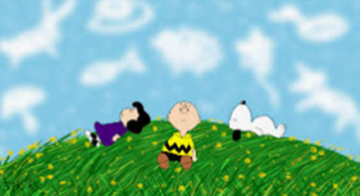 | Birds have been busy building their nests in the last few weeks. Can you try building a nest using loose materials indoors or outdoors. Remember birds don’t have hands – can you build it using tweezers?  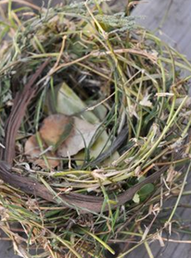 | We can’t go on holiday at the moment so bring those famous landmarks to your living room or garden using whatever you have to hand to make a model. It could be to scale or actual size if you have enough room or the landmark is small!  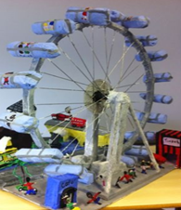 |  | 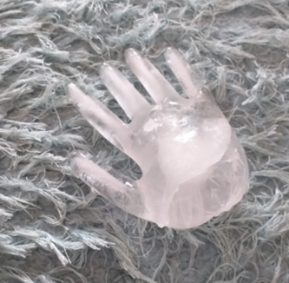  Holly in Class 2 made this frozen hand by filling a rubber glove with water and putting it in the freezer. You could make a few and set up a science investigation e.g. does a bigger hand take longer to melt than a smaller one?
Make sure you read a little every day. | Joe Wickes is running online PE sessions daily at 9am: https://www.youtube.com/channel/UCAxW1XT0iEJo0TYlRfn6rYQ |  | Check out the back catalogue of lessons at https://www.bbc.co.uk/bitesize/dailylessons

