02.06.20
Over the next few weeks, we are going to plan, draft and write a story of your choice. The type of story and where it is set is completely up to you. This week we are going to focus on the planning of the story.
First, you need to decide on the general structure of your story. There are a handful of plot lines that most stories follow/adapt. Today, please read through these plot ideas and decide which one you would like to base your story on.
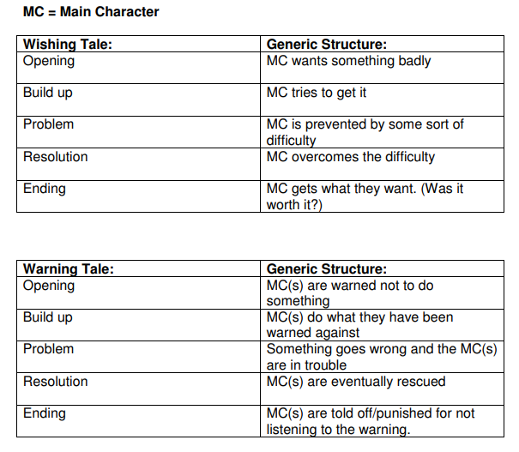
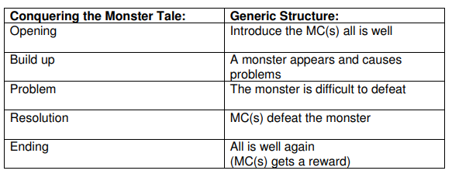
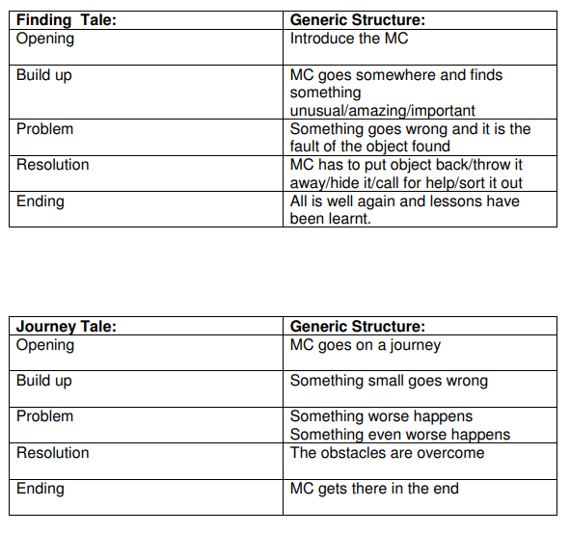
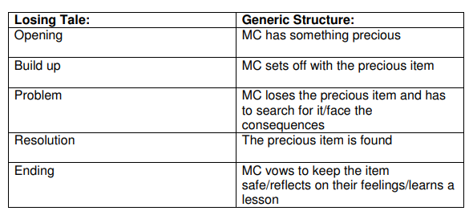

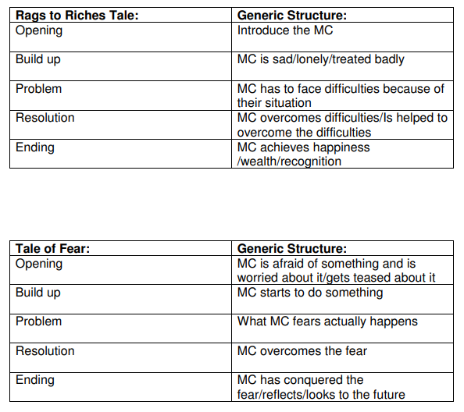
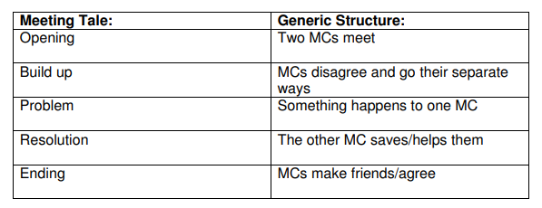
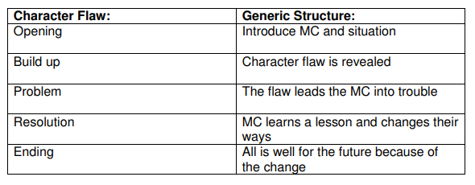
03.06.20
Decide on your setting and who your main character will be. Base this on something you are interested/passionate about. It might be a computer game, TV programme, a sport or a hobby like horse riding.
If you are looking for inspiration regarding a setting, check out these visual prompts: https://www.literacyshed.com/the-images-shed.html

Characters
The classroom door swung open and the new supply teacher strode in.
So tall she hardly fit through the door frame and dressed from head to
foot in purple velour, I hardly need to say she was an imposing figure.
“Siddown everyone,” she snarled, seizing and snapping Sarah Smith’s ‘Frozen’ ruler as she stalked across the room.
“She’s scary,” whispered Clare, “really scary!”
This passage contains the 3 main ways to convey a character. Can you work out what they are?

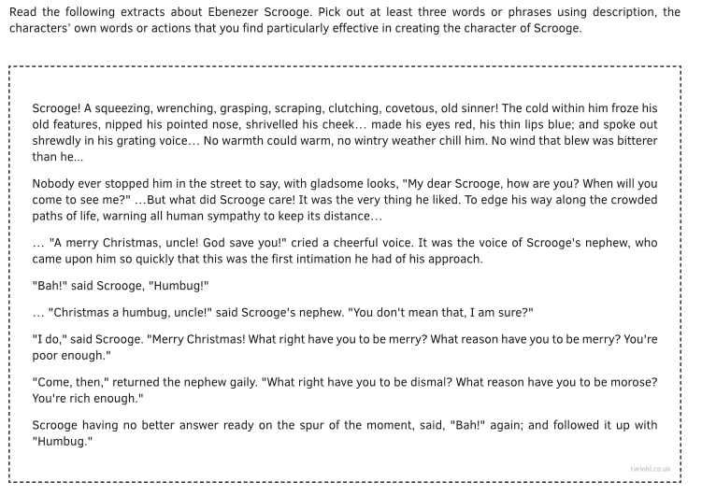

Now read this character description:
Mrs Smith was a horrible, ugly lady. She did mean things and nobody liked her.
Is this interesting?
When you create a character, you need to show, not tell.
This means you give the reader clues through varied description, speech and action, rather than spelling it out for them.
Could you do any better? See if you can improve the description of Mrs Smith.

Of all the old ladies Sarah had ever met, the oldest, ugliest and downright meanest was Mrs Smith. Every day, at home-time, she would stand at her gate, dressed in the same smelly, dirt-encrusted dress, shouting out obscenities, trying to scare the younger children. She never smiled, except if one of them happened to suffer a mishap, such as fall over. Then she would cackle evilly, like a bad audition for the Wizard of Oz.
“Poor old mad-woman,” you might say, but Mrs Smith was as sane as you are. She was just horrid.

Top Tips for Creating a Character
- Show – don’t tell!
- Use interesting descriptions appealing to a range of senses.
- Show what the character is like from what they say.
- Show what the character is like from what they do.
- You may also describe the character from how others react to them.

04.06.20/05.06.20
Get some initial ideas down on paper. You don’t need to worry about handwriting or spellings, you are just playing with ideas. There are no wrong answers. Put an idea down, if you don’t like it scribble it out. I find I need to talk through the ideas before I write them down, but do whatever works for you. Go back to the story plot you have chosen to follow and jot your notes down under the sub-headings:
- Opening
- Build-Up
- Problem
- Resolution
- Ending.

Get the bare bones of your plot down and then you can go back through your story and jot down any key vocabulary, descriptions or detail you want to add.
I think this is the most important part of the process so don’t rush it.

