Phonics/Reading
Monday |  |  | Tuesday |  |  | Wednesday |  |  | Thursday |  |  |  | Friday
Continue to access Letters and Sounds, phonics play and teach your monster to read – along with any apps and websites that you have found to be good for phonics.
Letters and sounds https://www.youtube.com/channel/UCP_FbjYUP_UtldV2K_-niWw/channels?view_as=public
Phonics play https://new.phonicsplay.co.uk/
Teach your monster https://teachyourmonstertoread.com
 |  | Write a list of words containing the sound of the day.  Mrs Adrew/Lynsey group: st  Mrs Penhaligan’s group: mp (stamp)  Mrs Hughes’ group: Please recap over the sounds from previous weeks, practise any that are tricky for you. |  |  | Write a list of words containing the sound of the day.  Mrs Adrew/Lynsey group: bl  Mrs Penhaligan’s group: nk (link) |  |  | Write a list of words containing the sound of the day.  Mrs Adrew/Lynsey group: gr  Mrs Penhaligan’s group: lp (pulp) |  |  | Write a list of words containing the sound of the day.  Mrs Adrew/Lynsey group: br  Mrs Penhaligan’s group: xt (text)
Choose a different way to practice your tricky words each day by using a dice to see what you need to do.
Write each word 3 times. | Write each word in rainbow colours. |  |  | Write the words all in CAPITALS. |  |  | Write the words in silly letters. |  |  | Write each word and then a word that rhymes. |  | Write a sentence for each word.
Mrs Andrew/ Lynsey  Chop chip chick church |  |  |  | Mrs Penhaligan  House love here where once |  |  |  |  |  | Mrs Hughes  Children climb most only both old cold gold hold told

Reading (at least 20 minutes a day) | Read your own book or share a story together. Every few pages look at and have a go at answering 1-3 of the vipers questions – see below.

Writing
 | Monday | Tuesday | Wednesday | Thursday | Friday
This week our story is Tiddler by Julia Donaldson
https://www.youtube.com/watch?v=qcTQADUywZY
Reception |  | Share the story together – if you do not have a copy then you can have it read to you via youtube.  Then make up your own story for why he was late for the day. | Tiddler was busy daydreaming up an excuse and ended up getting caught in the fisherman’s net. His class thought he was lost. Can you make a ‘missing’ poster for Tiddler? | Think about the moment when Tiddler was caught in the net. How do you think he was feeling and why? Draw a picture of Tiddler with a thought bubble explaining your ideas. | Tiddler ended up going on a real life adventure the day he was caught. Can you write your own adventure story for Tiddler to go on next.
Year 1
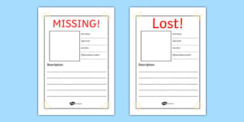
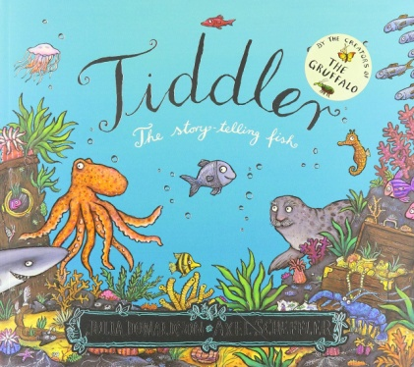

Maths
Monday | Tuesday | Wednesday |  | Thursday |  | Friday
Please access your year group videos on White Rose Home Learning. Worksheets will be sent.
Reception - https://whiterosemaths.com/homelearning/early-years/
Year 1 - https://whiterosemaths.com/homelearning/year-1/

Please log in to Mathletics and complete your tasks on there.

BBC Bitesize home learning also have some great activities and videos to get you thinking.

Make a map. Draw on grid lines and then write/give directions for an object to move around the map. |  |  | Make a clock using a paper plate and practise setting different o’clock and half past times. |  | Make/bake a pizza/cake. Practise cutting it in to half and quarter. Now can you share out some toys/snacks so you and another person have an equal amount?

