Wider Curriculum
Below is a list of suggested activities – you may have your own ideas and projects that you want to try.
Learn a new song. ‘Shake my sillies out’ can be found on Sing Up with a video to help you to learn it. When we get back together we can try singing it in class.  www.singup.org/singupathome/song-of-the-week | Create your own board game.  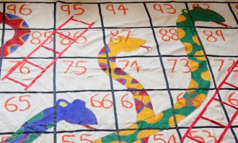  It could be Snakes and Ladders, Guess Who ( using your friends and family), or you might have a great idea for your very own game! Have fun playing it with your family. | Make a volcano. The instructions can be found on the link below.  What happens if you change the amount of vinegar and baking powder?  https://www.nhm.ac.uk/discover/how-to-make-a-volcano.html |  | Express yourself in nature. Find something natural as a stimulus for art. Try creating your artwork in the style of Paul Signac.  He used a style called pointillism which is where you use small dots of colour. If you don’t have paint, try using felt tips or coloured pencils. There are some examples of his art below.  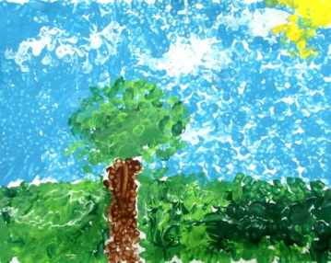  A child’s version of pointillism.
Do something kind for someone in your family everyday this week. Maybe you can make a kindness jar where you write down why you love someone and post it in a jar. When you have lots of pieces of paper in the jar, decorate it and give it to the person. | https://www.bbc.co.uk/teach/class-clips-video/history-ks2-d-day/zf49rj6  June 6th is D Day. Watch the video and find out as much as you can about this important day. |  | Year 3s and 4s, do you remember when we used to do our daily mile? Try and walk at least a mile each day? Can you walk a little further each day? What is the furthest you can walk?

Paul Signac’s paintings using pointillism.
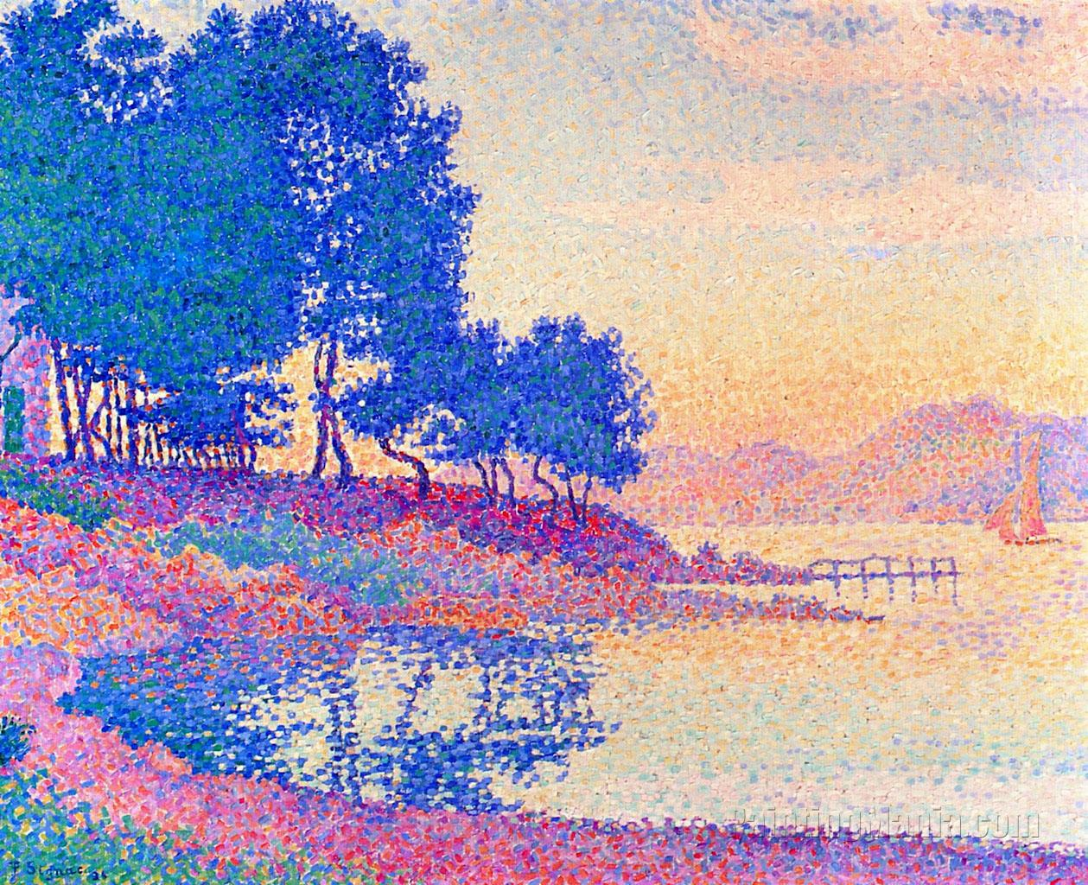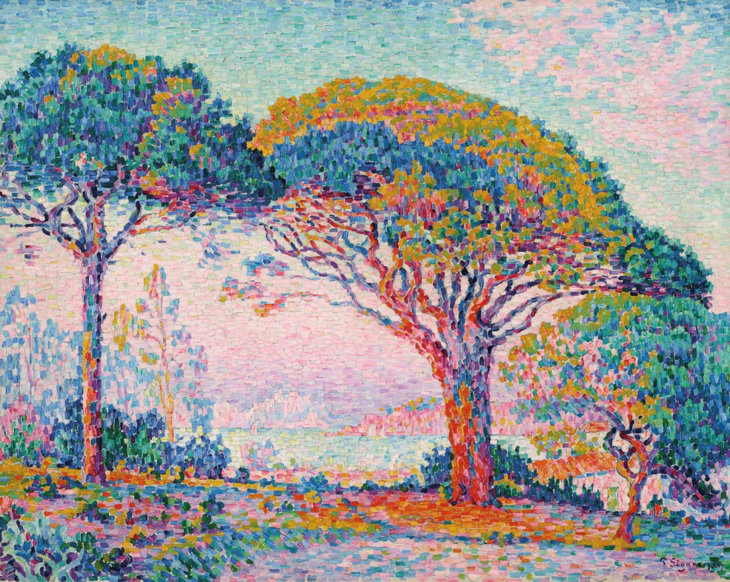

An example of pointillism:
