Phonics/Reading
Monday | Tuesday | Wednesday | Thursday | Friday
Continue to access Letters and Sounds, Phonics play and Spelling frame.
Phonics play: https://new.phonicsplay.co.uk/
Mrs Penhaligan, Mrs Hughes, Jade’s groups:https://www.youtube.com/channel/UCP_FbjYUP_UtldV2K_-niWw/channels?view_as=public
Mrs Dunn’s, Mrs Rice’s and Mr Hannah’s groups can access games and activities on: https://spellingframe.co.uk/
Write a list of words containing the sound of the day.  Mrs Penhaligan’s group: mp  Mrs Hughes’ group: You don’t have any sounds anymore. You now have extra spellings! | Write a list of words containing the sound of the day.  Mrs Penhaligan’s group: nk | Write a list of words containing the sound of the day.  Mrs Penhaligan’s group: lp | Write a list of words containing the sound of the day.  Mrs Penhaligan’s group: xt | Write a list of words containing the sound of the day.  Mrs Penhaligan’s group: ft

Choose a different way to practice your tricky words each day from the list below.

Write the consonants in one colour and the vowels in another. E.g.  month | Write them in lower case and upper case. E.g.  month  MONTH | Write your words in alphabetical order | Write them as a staircase. E.g.  h  ho  hou  hour | Use each of your spellings in a sentence
Mrs Dunn  Monday  Tuesday Wednesday Thursday Friday Saturday Sunday year month  hour | Mrs Rice  Possibly potatoes ordinary particular possess possession pressure perhaps popular peculiar | Mrs Penhaligan  house  love  here  where  once | Mrs Hughes  Children, climb  Most, only, both, old, cold, gold, hold, told | Jade  child, gold, after, path, sure, only, class, Mr, cold, beautiful
Mr Hannah’s group see Class 3 page for activity.
Reading (at least 20 minutes a day) | Read your own book or share a story together. Every few pages look at and have a go at answering 1-3 of the vipers questions – see below.  If you are struggling to find reading material, Oxford Owl are offering free access to E books: https://www.oxfordowl.co.uk/for-home/find-a-book/library-page.  This site also offers reading books online:  https://readon.myon.co.uk/library/search.html  Try the attached reading comprehension. Either print out or read it on screen and write down your answers/ tell a grown up your answers. Green and Blue tables, there are 3 different levels to choose from. If you are on the Green or Blue table and in my reading group, I would recommend you try the one with 1 star at the bottom, Mrs Rice’s group the one with 2 stars and Mr Hannah’s group the one with 3 stars.  Remember to ask for sponsorship for Read for Good!
Writing:
The Magic Tree. Look at the picture below and read the start of the story which follows it. You might need to ask a grown up to help you read this as it has some really tricky words in! Check that you understand what all the words mean especially the red words.
Monday | Tuesday | Wednesday | Thursday | Friday
Answer these questions. You might want to just talk about some of them but try and write down the answers to at least some of them.  What do you think has caused the destruction all around the tree? Why has this one tree survived? If you walked through the portal, what would happen to you? What would you see? If this portal led to another world, would you go through it or stay on Earth, even if you had no idea what could happen? Is it good to take risks? Are some risks riskier than others? | Sentence challenge:  A preposition is a word that shows the relationship between one thing and another.  It may tell you where a thing is in relation to something else. E.g. The green, shining door appeared inside the tree.  It may tell you when something is in relation to another event. E.g. The portal would not close until the storm had ended.  Try and write at least 3 sentences which each contain a preposition. Some examples of prepositions are:  Behind  Under  Among  Between  Above  After  Before | Perfect picture!  Imagine you have walked through the open portal into the world inside the tree. Draw and describe what you can see. | What happens next?  Can you continue the story?  What has happened to all the other trees? What is inside the portal? Where does it lead you to? Do you learn anything from your journey into the portal? Do you come back to Earth afterwards or do you stay in the other world? | Check and improve.  Read your story to a grown up and ask them to check it makes sense and to check some of your spellings. Have you remembered full stops, capital letters, exclamation marks and commas? Have you tried to use AMAZING vocabulary?  If you would like to email your story to me, PLEASE do. I’m missing all your lovely ideas!

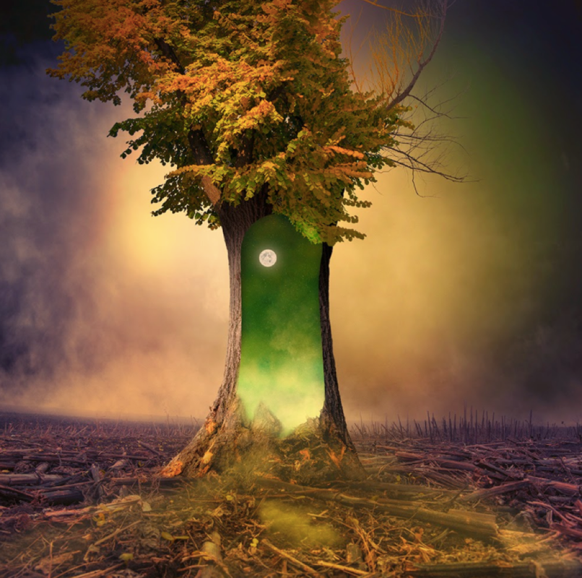
The tree was all that remained. A solitary figure, it stood there in defiance of the destruction surrounding it. The bark had begun to peel away, one piece at a time, joining the wreckage of other trees that lay scattered across the scorched earth. This tree was different to the other trees. It contained magic. It contained hope…

Maths
Monday | Tuesday | Wednesday | Thursday | Friday
Complete the assigned tasks on Mathletics.

As a supplement to mathletics, follow the link to White Rose Maths and you will find a series of lessons, with short videos. Worksheets have been emailed to you. If there are any problems, please let me know.
Red, Orange, Yellow Tables: https://whiterosemaths.com/homelearning/year-2/

Green and Blue tables, choose either of these:
https://whiterosemaths.com/homelearning/year-3/
https://whiterosemaths.com/homelearning/year-4/

BBC bitesize also has daily maths activities.

