Wider Curriculum
Below is a list of suggested activities – you may have your own ideas and projects that you want to try.
Sign up to The Wildlife Trusts 30 days wild where you can take part in loads of wild adventures outside.  https://action.wildlifetrusts.org/page/57739/petition/1 | What cleans pennies best? Set up an experiment to answer this question using whatever you can find at home. Some ideas are:  lemon juice, cola, ketchup, vinegar, salt water, milk, orange juice, soap.  Make a prediction, think about how you will make sure it is a fair test. E.g it won’t be fair if you leave one penny in the milk for 30 minutes and the one in soap for 2 hours.  What worked best? Why do you think that is? You could try and find out why.  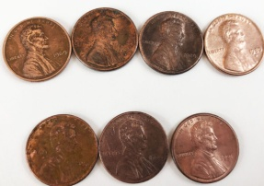 | Find a pebble or stone to decorate. Use paint or felt tips to decorate.  Or find lots of smaller stones or pebbles to create a picture.  See below for some ideas.
PE challenge. Have a go at some mini Muay Thai sessions with British champion Kelly Haynes.  https://primarypeplanning.com/home-pe-mini-muay-thai/ | Google BBC bring the noise or follow this link:  https://www.bbc.co.uk/games/embed/bring-the-noise?exitGameUrl=http%3A%2F%2Fbbc.co.uk%2Fteach%2Fbring-the-noise%2Feyfs-ks1-music-play-it-bring-the-noise%2Fz4sq92p  You can experiment with different layers of music, try keeping a beat, or experiment with different instruments. |  | Year 3s and 4s, do you remember when we used to do our daily mile? Try and walk at least a mile each day? Can you walk a little further each day? What is the furthest you can walk?

Pebble Art ideas:
