Wb. 08.06.20
This week we are going to focus on writing the opening of our story.

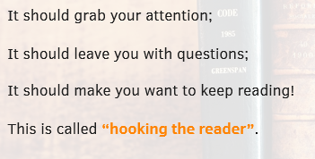

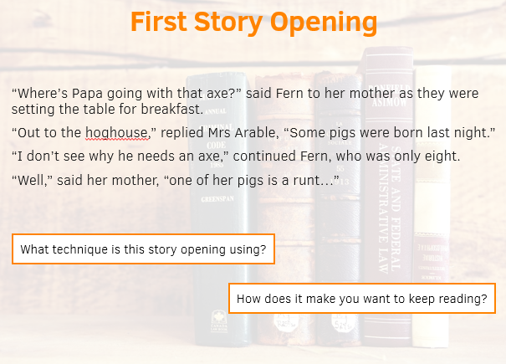
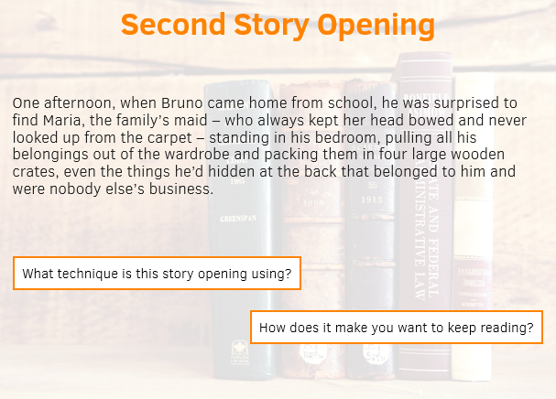

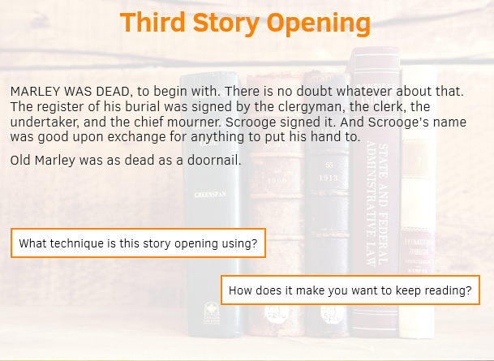
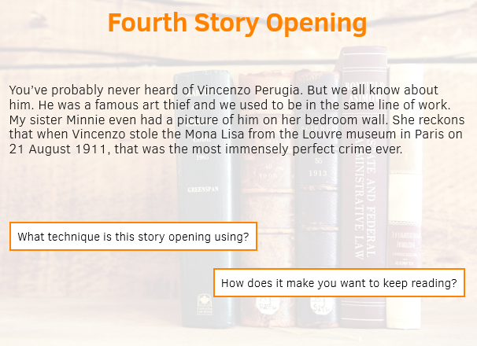
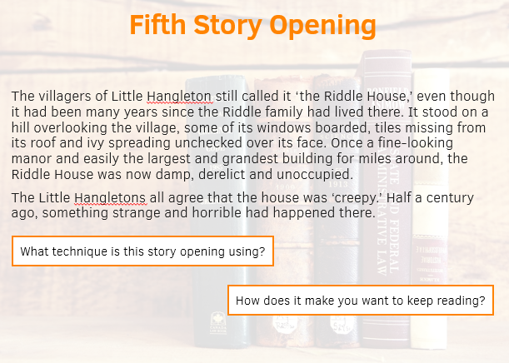

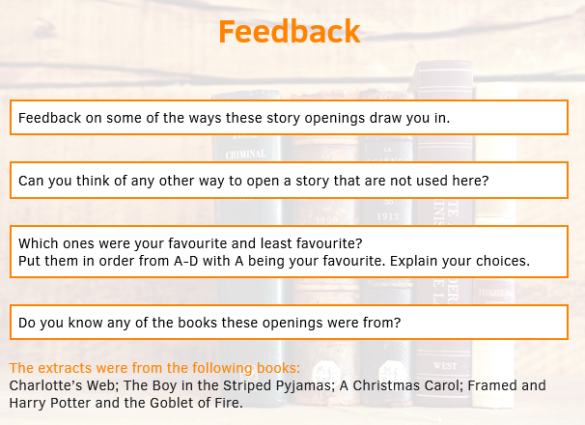

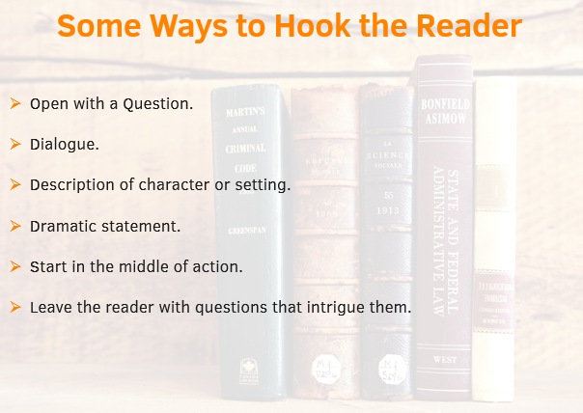
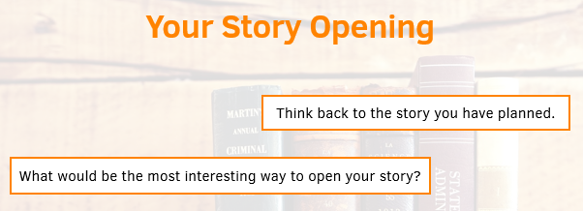

Remember your planning from last week. Your story has 5 stages: opening, build-up, problem, resolution and ending. Don’t jump into your build-up and problem yet. Lots of children make this mistake. Focus on introducing your characters and setting.

09.06.20
Read over what you have written from yesterday. Does it make sense? Have you used ‘show not tell’ for introducing you character and setting?
Today I would like you to continue drafting your opening, but please review the sentence structures we used last week. Can you incorporate them into your writing?

10.06.20
Today is the final day for drafting the opening of your story. Today I would like you to focus on vocabulary. Have you used adventurous vocabulary in your writing so far? Read over your work and think if you could improve your writing by using different vocabulary. You have the Year 3 and 4 and Year 5 and 6 spelling sheets to help you from last week. There are also so additional word mats below.
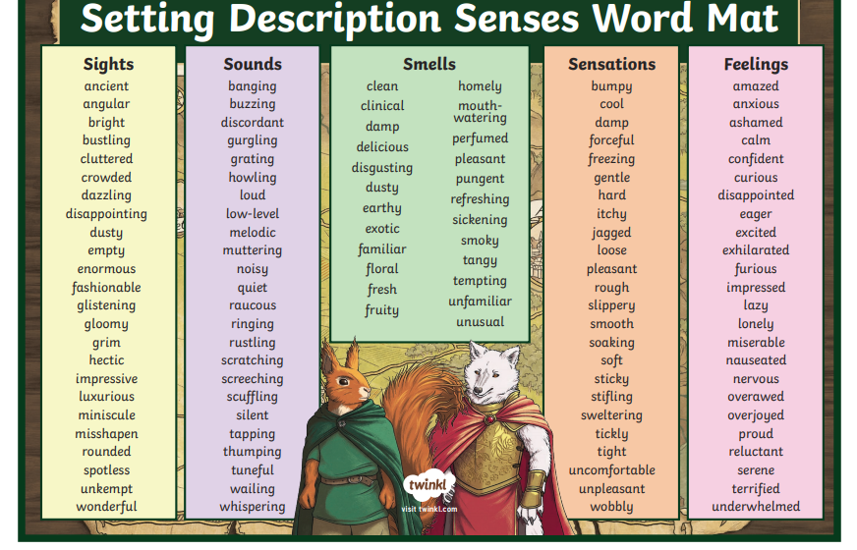
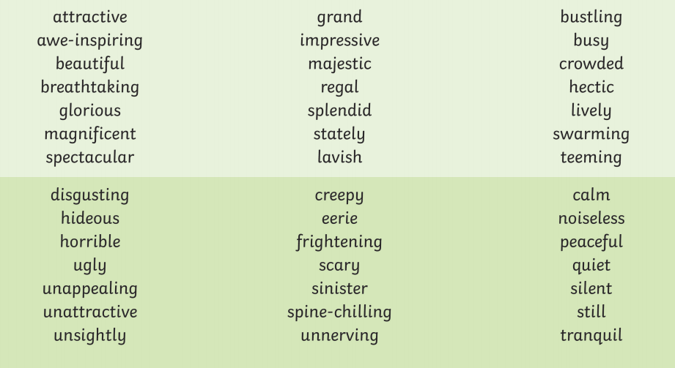
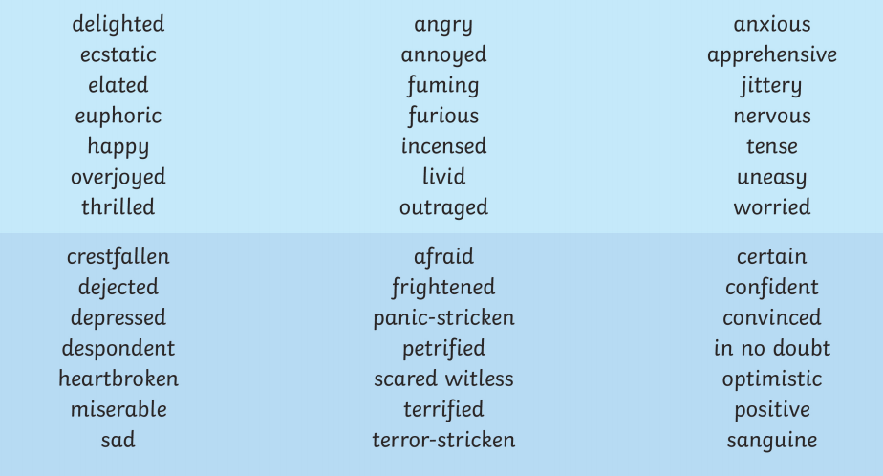
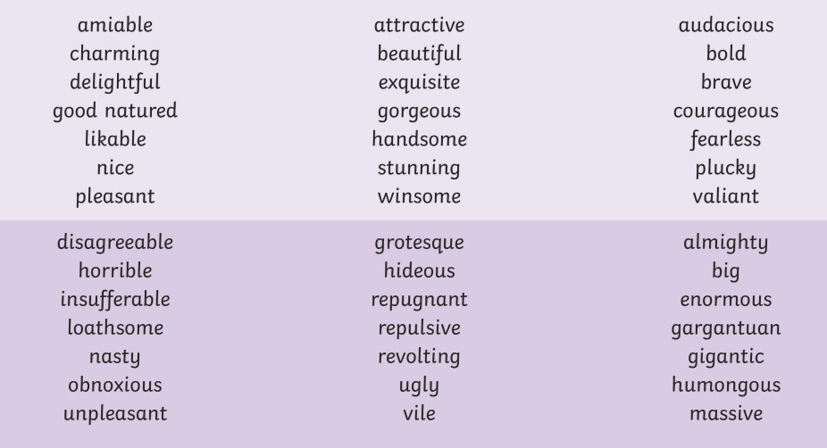

11.09.20 – 12.09.20
Over the next couple of days we are going to write up the opening of our story focusing on presentation and handwriting.
- Ensure words are sat on the line.
- Ensure ascending and descending letters are clear.
- Handwriting is joined.
- There is a clear space between each word.

