Phonics/Reading
Monday |  |  | Tuesday |  |  | Wednesday |  | Thursday |  |  | Friday
Letters and sounds https://www.youtube.com/channel/UCP_FbjYUP_UtldV2K_-niWw/channels?view_as=public
Phonics play https://new.phonicsplay.co.uk/
Teach your monster https://teachyourmonstertoread.com
Recall all letter sounds (s a t p i n m d g o c k ck e u r h b f f l ll ss j v w x y z qu sh ch th ng ai ee igh oa oo ar or ur ow oi ear air ure)
Mrs Adrew/ Lynsey | This week our sound will be ‘ai’  Write a list of ai words. | Read the sentences –  I went to sail my boat.  The train is fast.  I saw a snail on a rock. |  |  | Write the sentences –  Can you hammer the nail?  The cat has a long tail. |  | Make some ‘ai’ word flash cards. Write the word and draw a picture to go with it. |  |  | Complete the ‘ai’ spelling activity sheet.
Mrs Penhaligan | ow and ou  Write a list of words.  Have a go at the sorting activity. | Read the sentences –  Now I have got a goat that is brown and makes a loud sound.  Can we go into town on the train and have a look around? |  |  | Write the sentences –  How old are you now?  Can you make a loud sound with your mouth? |  | Make an ow and ou book – on each page write a word and draw a picture to go with it. |  |  | Play the sound family game or make up your own.
Mrs Hughes | Please recap over the sounds from previous weeks, shown above and practise any that are tricky for you. | Read the captions – How many of them can you see?  A brown shed.  A damp drain.  A nest in a treetop.  A green frog.  A gust of wind. |  |  | Start to make a phonics book. Choose a different sound for every page. Write some words and draw pictures to match. |  | Make an obstacle course for your family. Remember to include labels.  start jump spin stop stamp end  Can you think of any other labels to add?  Draw and label the course you made.
Choose different ways to practise your spellings this week.
*Rainbow write
*Paint
*Chalk
*Make each word with sticks
Mrs Andrew/ Lynsey  chain rain snail train snail trail  maid hail nail tail |  |  |  | Mrs Penhaligan  now how brown down  town out about mouth  sound you* |  |  |  |  | Mrs Hughes  dolphin alphabet  phonics elephant when where which wheel  while white

Reading (at least 20 minutes a day) | Read your own book or share a story together. Every few pages look at and have a go at answering 1-3 of the vipers questions – see below.

Writing
 | Monday | Tuesday | Wednesday | Thursday | Friday
This week our story is The Singing Mermaid by Julia Donaldson.
https://www.youtube.com/watch?v=mRBzaKMHDDw
Reception | The mermaid is the main character in the story. Can you write a character description about her, detailing what she looks like, what skills she has and what you know about her personality from the story? Include a picture and sentences/words. | In the story, the mermaid decides to go and live at the Circus. Can you make a poster advertising the mermaid’s Circus act? | If you could perform in the circus, what act would you like to do? Would you need any special skills for your act, such as the ability to juggle, weight lift or balance? Put on a Circus show for your family. | Sam Sly convinced the mermaid that she should perform at the circus. Her friends tried to stop her, but she didn’t listen to them. Can you write a letter to the mermaid persuading her not to go? | If you could be a mermaid/ merman for the day, and have your own tail, where would you swim and what would you do? Draw a picture showing what you would get up to with sentences to explain. A bit like a story map!
Year 1
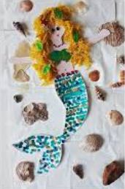
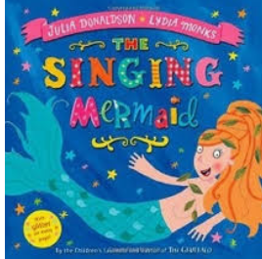

Maths
Monday | Tuesday | Wednesday | Thursday | Friday
Please access your year group videos on White Rose Home Learning. Worksheets will be sent.
Reception - https://whiterosemaths.com/homelearning/early-years/
Year 1 - https://whiterosemaths.com/homelearning/year-1/

Please log in to Mathletics and complete your tasks on there.

BBC Bitesize home learning also have some great activities and videos to get you thinking.

