Wider Curriculum
If you haven’t already done so then sign up to The Wildlife Trusts 30 days wild where you can take part in loads of wild adventures outside.  https://action.wildlifetrusts.org/page/57739/petition/1 |  |  | 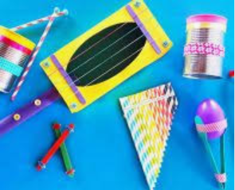  Can you find some objects around the house or garden to make an instrument? Maybe you could make a few different instruments and make up some music to go with your circus act? How can you record your piece of music so you know what to play when?
The mermaid is half fish, half human. Can you create your own creature that is a mix of 2 or more animals? Where would your creature live? What would they eat? |  | 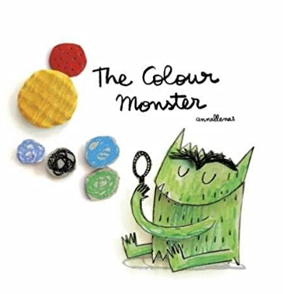  Share the story of The Colour Monster. Draw a picture of your own colour monster, colour him in to show how you are feeling and write a sentence to explain.  https://www.youtube.com/watch?v=Ih0iu80u04Y |  |  | Make your own mermaid/ merman tail. 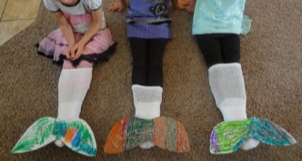
A P.E. challenge for this week.  Have a at some mini Muay Thai sessions with British Champion Kelly Haynes.  https://primarypeplanning.com/home-pe-mini-muay-thai/ | 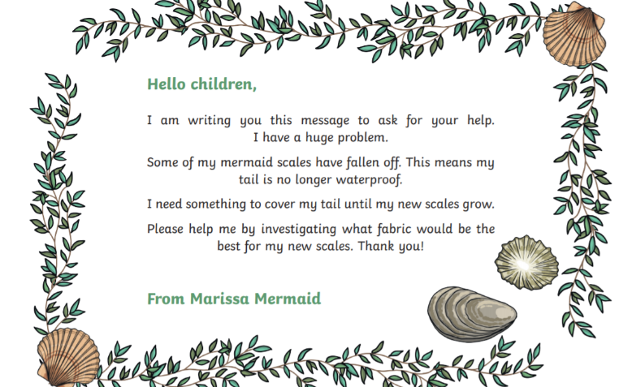 |  |  | 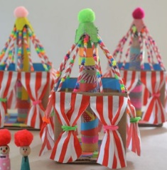  Build a model of a circus tent which the mermaid may have been happier working in.  