Wider Curriculum
Below is a list of suggested activities – you may have your own ideas and projects that you want to try.

We are now in the official first month of summer.  What can you find out about June?  What events happen in June?  What is the birthstone and flower of June?  What is the history of June?  How do we say June in a different language?  This website will help. https://www.ducksters.com/history/juneinhistory.php | Our school parable is The Lost Sheep.  Read the story through and look at the Artwork for another parable The Prodigal Son. You will see that this is the whole story represented in a picture.  Can you create a picture which retells the story of The Lost Sheep? | There are lots of birds in and around our garden in June.  Can you identify and tally the birds you see and look out for any that are not on the attached list?
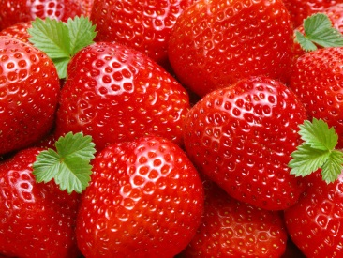
Lots of lovely strawberries around why not make some scones with the attached recipe.

Email Mr Hannah @ head@duloeprimary.co.uk or Mrs Wright twright@duloeprimary.co.uk
to let us know what you have been up to.

