Phonics/Reading
Monday |  |  | Tuesday |  |  | Wednesday |  | Thursday |  |  | Friday
Letters and sounds https://www.youtube.com/channel/UCP_FbjYUP_UtldV2K_-niWw/channels?view_as=public
Phonics play https://new.phonicsplay.co.uk/
Teach your monster https://teachyourmonstertoread.com
Recall all letter sounds (s a t p i n m d g o c k ck e u r h b f f l ll ss j v w x y z qu sh ch th ng ai ee igh oa oo ar or ur ow oi ear air ure)
Mrs Adrew/ Lynsey | This week our sound will be ‘igh’  Write a list of igh words. | Read the sentences –  She saw a light in the dark shed.  In the night I sleep in my bed.  Do not fight with him! |  |  | Write the sentences –  The sun is bright today.  I put the light on in the room.  The owl is in the tree at night. |  | Make an ‘igh’ book.  On each page draw a picture and write the ‘igh’ word to match. |  |  | Have a go at the ‘roll and read’ game.
Mrs Penhaligan | e spelt with ‘y’  Write a list of words ending with ‘y’ that make an ‘ee’ sound, e.g. funny | Read the sentences –  I met a clown and he was very funny.  Looking at the sunny beach made me feel dizzy. |  |  | Write the sentences –  Can you come to my family party?  The jelly was very wobbly. |  | Make ‘y’ flashcards – on each piece of paper write a word and draw a picture to go with it. |  |  | Can you write your own ‘y’ story? Try and include all of the words from your spelling list.
Mrs Hughes | How many words can you write that start with the following sounds?  st, tr, gr, fl | Get an adult at home to write out st, tr, gr and fl words and hide them around the house and garden – can you find and read them? |  |  | Continue to add to your phonics book that you started last week. Can you add anymore ‘sound’ pages or words? |  | Practise any of the letter sounds that are tricky for you. |  |  | Build a secret den! Use a secret password to allow people to get in. Name three words that start with ‘st’ before entering. Change the ending sounds each time they enter.
Choose different ways to practise your spellings this week.
*Rainbow write
*Paint
*Chalk
*Make each word with sticks
Mrs Andrew/ Lynsey  night light bright sight high right sigh thigh might tight |  |  |  | Mrs Penhaligan  very happy funny party family dizzy smelly silly jolly sunny |  |  |  |  | Mrs Hughes  unhappy undo unload unfair unlock unwrap unzip untidy unwell unkind

Reading (at least 20 minutes a day) | Read your own book or share a story together. Every few pages look at and have a go at answering 1-3 of the vipers questions – see below.

Writing
 | Monday | Tuesday | Wednesday | Thursday | Friday
This week are still using the story of The Singing Mermaid by Julia Donaldson.
https://www.youtube.com/watch?v=mRBzaKMHDDw
Reception | Create your own mermaid or under the sea character? What do they like to do? Do they have a special talent? What is their name? | Draw a story map to show the adventure that your character goes on. Who do they meet? Where do they end up? | Can you write and illustrate your own mermaid story?  Remember to;  *Start with a capital letter  *Use finger spaces between your words  *Spell new and tricky words using your phonics  *End with a full stop  *Use adjectives to make your writing exciting. |  | Make a front cover for your book. What will your story be called?
Year 1
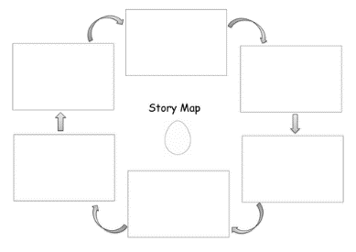
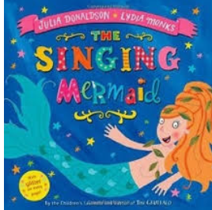

Maths
Monday | Tuesday | Wednesday | Thursday | Friday
Reception - https://whiterosemaths.com/homelearning/early-years/
Year 1 - https://whiterosemaths.com/homelearning/year-1/

Please log in to Mathletics and complete your tasks on there and look at the video’s on BBC Bitesize.

