Wider Curriculum
Choose a skill to practise to use in your circus show. Can you get everyone in the family to learn something new to show to the audience?  Maybe juggling, gymnastics or a funny clown act. |  |  | 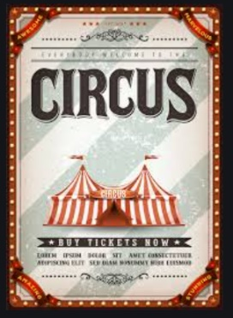  Create a poster advertising your circus. Make it big and bold to catch the attention of people.
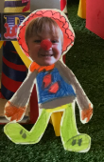  Turn yourself in to a clown! Use a photograph of your head cut it out and stick it on to plain paper then just draw on your clown body. You might like to add a hat, bright clothes, a red nose, crazy hair, big shoes, anything you can think of. |  | 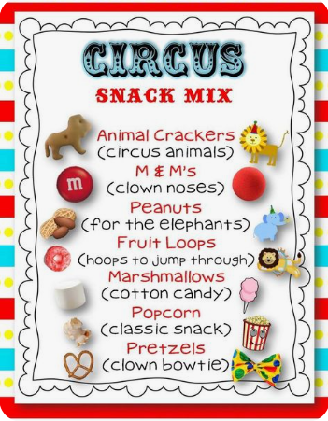  Every circus needs a snack stall. Can you create a snack menu and price list for your performance day? |  |  | Make a programme of events. What order will your acts take to the stage?
Hold a circus performance. I’d love to see any photos or videos of your acts. | BBC bring the noise – use the link below to access the music program . Explore the different parts of the ‘Music Time’ song. Can you change the words to make it a circus song?  https://www.bbc.co.uk/games/embed/bring-the-noise?exitGameUrl=http%3A%2F%2Fbbc.co.uk%2Fteach%2Fbring-the-noise%2Feyfs-ks1-music-play-it-bring-the-noise%2Fz4sq92p |  |  | Build your own ‘Circus tent’ den. Maybe hang a sheet from the ceiling or make a roof on your trampoline. Decorate it with colourful decorations. Make some bunting or paper chains.

