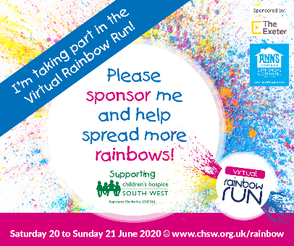
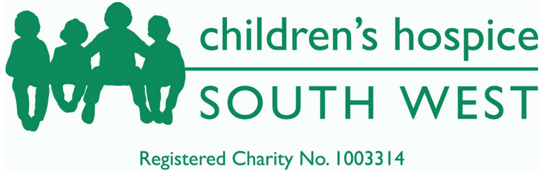

Dear Parents and Carers,
For more than 25 years, Children's Hospice South West has been caring for children with life-threatening conditions by providing children's hospice and professional family support services. They are dedicated to making the most of short and precious lives through the provision of the best possible hospice care for children and young people with life-limiting conditions. The care offered at each of their three hospices is not just about medical and nursing support for sick children but enriching lives of the children and their whole family.
Unfortunately, due to the Covid 19 pandemic, Children’s Hospice South West have not been able to run their ‘Rainbow Runs’ this year. This will mean a drop in approximately £150,000 of funding to support the children they care for.
Therefore, Children’s Hospice South West are running a virtual ‘Rainbow Run’ over this weekend. Please could I encourage as many families to visit their website https://www.chsw.org.uk/news/virtual-rainbow-run-childrens-hospice and join their virtual run this weekend. Simply complete 5k (by running, walking, biking, skating, hopping…) and help spread more rainbows by wearing the brightest colours possible. Whether you rock a tie-dye tee, get crazy with hair colours or go fully fledged rainbow warrior with flashy face paint, we want you to get colourful and creative at home. Choose to complete it in one go, or shorter bursts over the two days. Entry is free but everyone who registers to take part and raises some sponsorship money will receive a Rainbow Run medal. The suggested minimum sponsorship target is £15 for adults and £9 for children.
If your child is attending school next Monday, we invite them to attend in as colourful clothes as possible and we will complete 5k in school, during the course of the day. However, you will still need to register your child at home.
If you complete this challenge, please send any photos to your class teacher and we can make a display within school.
The more people who register, the more money we can raise for this great cause.
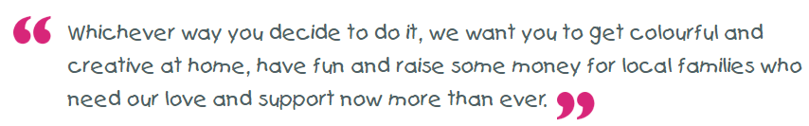
Best wishes,
Mr Hannah

