Wider Curriculum
Write some acts of kindness on to individual pieces of paper and put them in a jar. Pick one each day and try to complete it. |  | Hubbub  A virtual music festival Tuesday 23rd June  Join in with the online music workshops from the Cornwall Music Education Hub.  http://www.cornwallmusiceducationhub.org/events-news/hubbub-free-music-festival-for-children-and-young-people/
Cornwall Virtual School Games  22nd – 26th June  See the attached information regarding the order of events for the week, challenge cards, demonstration videos and submitting results. This sounds like it is going to be lots of fun and will get everyone involved.  There is an opening ceremony at 10am on Monday 22nd June which you can watch through the Cornwall School Games Facebook page, Active Cornwall You Tube Channel or via the Active Cornwall website.  http://www.activecornwall.org/cornwallschoolgames/the-virtual-games |  |  | Design a T-shirt that could be worn at the school games. Look at the school games values – can you include these in your design? Maybe use the colours of each value.
Create your own eatwell plate by drawing pictures or cutting pictures from magazines.  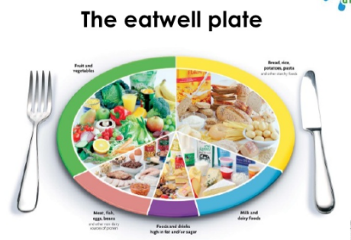 | Plan a day of meals for your family. Use the eatwell plate to help you. Make sure you include something from each food group to have a balanced diet.  Breakfast  Lunch  Tea  Drinks  Snacks |  | Have a look at the mindfulness challenge cards. Pick a few and take some time to be quiet and relax. Encourage everyone in the house to take part.

