Phonics/Reading
Monday | Tuesday | Wednesday | Thursday | Friday
Continue to access Letters and Sounds, Phonics play and Spelling frame.
Phonics play: https://new.phonicsplay.co.uk/
Mrs Penhaligan, Mrs Hughes, Jade’s groups:https://www.youtube.com/channel/UCP_FbjYUP_UtldV2K_-niWw/channels?view_as=public
Mrs Dunn’s, Mrs Rice’s and Mr Hannah’s groups can access games and activities on: https://spellingframe.co.uk/
Mrs Penhaligan’s group:  ear  Compile a list of words that have the digraph or trigraph in. | Mrs Penhaligan’s group:  Read the sentences:  The boy hurt his leg and he had lots of tears. My beard has got longer this year. I use my ear to hear the sounds in the town. | Mrs Penhaligan’s group:  Write sentences using your spelling list words. How many can you write? | Mrs Penhaligan’s group:  Play the ‘ear’ read and roll game. | Mrs Penhaligan’s group:  Make ‘ear’ flashcards – on each piece of paper write a word and draw a picture to go with it.
Mrs Hughes:  Compound words (2 words to make 1) Farmyard Football How many more can you think of? | Mrs Hughes:  Look at some different books – can you find any compound words in them? | Mrs Hughes:  Look at the pictures and make the compound words. Write out a list of the words you find. | Mrs Hughes:  Use your spelling words to write sentences. Draw pictures to go with each sentence. | Mrs Hughes:  Play compound word bingo

Choose a different way to practice your tricky words each day from the list below.

Draw a flower with 10 petals. Write a spelling on each petal. | Write each word 3 times in your best handwriting | Use each of your spellings in a sentence | Make a mnemonic to remember each word:  people = People Eat Omelettes, People Like Eggs | Ask someone to test you on your spellings.
Mrs Dunn  other  brother  mother  another  smother  nothing  Monday  always  also  almost  although | Mrs Rice  disappoint  disagree  disobey  inactive  incorrect  illegal  immature  imperfect  impossible  impatient | Mrs Penhaligan  ear  tear  gear  dear  hear  beard  near  year  clear  fear | Mrs Hughes  football playground farmyard bedroom blackberry lighthouse sometimes bathroom classroom teatime | Jade  find  both  every  hour  behind  busy  money  poor  most  told
Mr Hannah’s group see Class 3 page for activity.
Reading (at least 20 minutes a day) | Read your own book or share a story together. Every few pages look at and have a go at answering 1-3 of the vipers questions – see below.  If you are struggling to find reading material, Oxford Owl are offering free access to E books: https://www.oxfordowl.co.uk/for-home/find-a-book/library-page.  This site also offers reading books online:  https://readon.myon.co.uk/library/search.html  Try the attached reading comprehension. Either print out or read it on screen and write down your answers/ tell a grown up your answers. There are 3 different levels to choose from. ( 1 star at the bottom is the easier level, 2 stars middle, 3 stars harder level) . If you are on the Green or Blue table and in my reading group, I would recommend you try the one with 1 star at the bottom, Mrs Rice’s group the one with 2 stars and Mr Hannah’s group the one with 3 stars.  Remember to ask for sponsorship for Read for Good!

Writing:
This week we are using a picture as a stimulus for our writing. There are no right or wrong ideas – it’s up to you. Look at the picture below and work through the activities. Some of you who find writing a challenge, might talk about a lot of your ideas and write down one or two sentences. Others may write and write!
Monday | Look at the picture and try and answer these questions:  - Where did the UFO come from?  - Who – or what – is controlling it?  - Why are they taking the tricycle?  - Who does the tricycle belong to?  - Why was the child here alone?  - How is the child feeling?  - What will happen next?
Tuesday | You are going to pretend you are the child in the picture. Draw a story map or plan your story. Remember a story needs a beginning, middle and end. Include any brilliant vocabulary you want to use on your plan
Wednesday | Start writing your story and try and write the beginning and middle. Remember you are the child, so use the first person ( I was feeling... I wandered ....)  Beginning: Set the scene – where are you, why are you there?  Middle: the UFO and tricycle
Thursday | Read through what you have written. Then write the end.
Friday | Read through your whole story. Can you improve it by using better vocabulary? Are there spelling mistakes which you can correct? Does it make sense? Have you missed words out? Have you remembered full stops, capital letters, commas? Ask a grown up or older brother or sister to help you. I would love to read your finished stories, so please email them to me if you can. We will read them out in class!
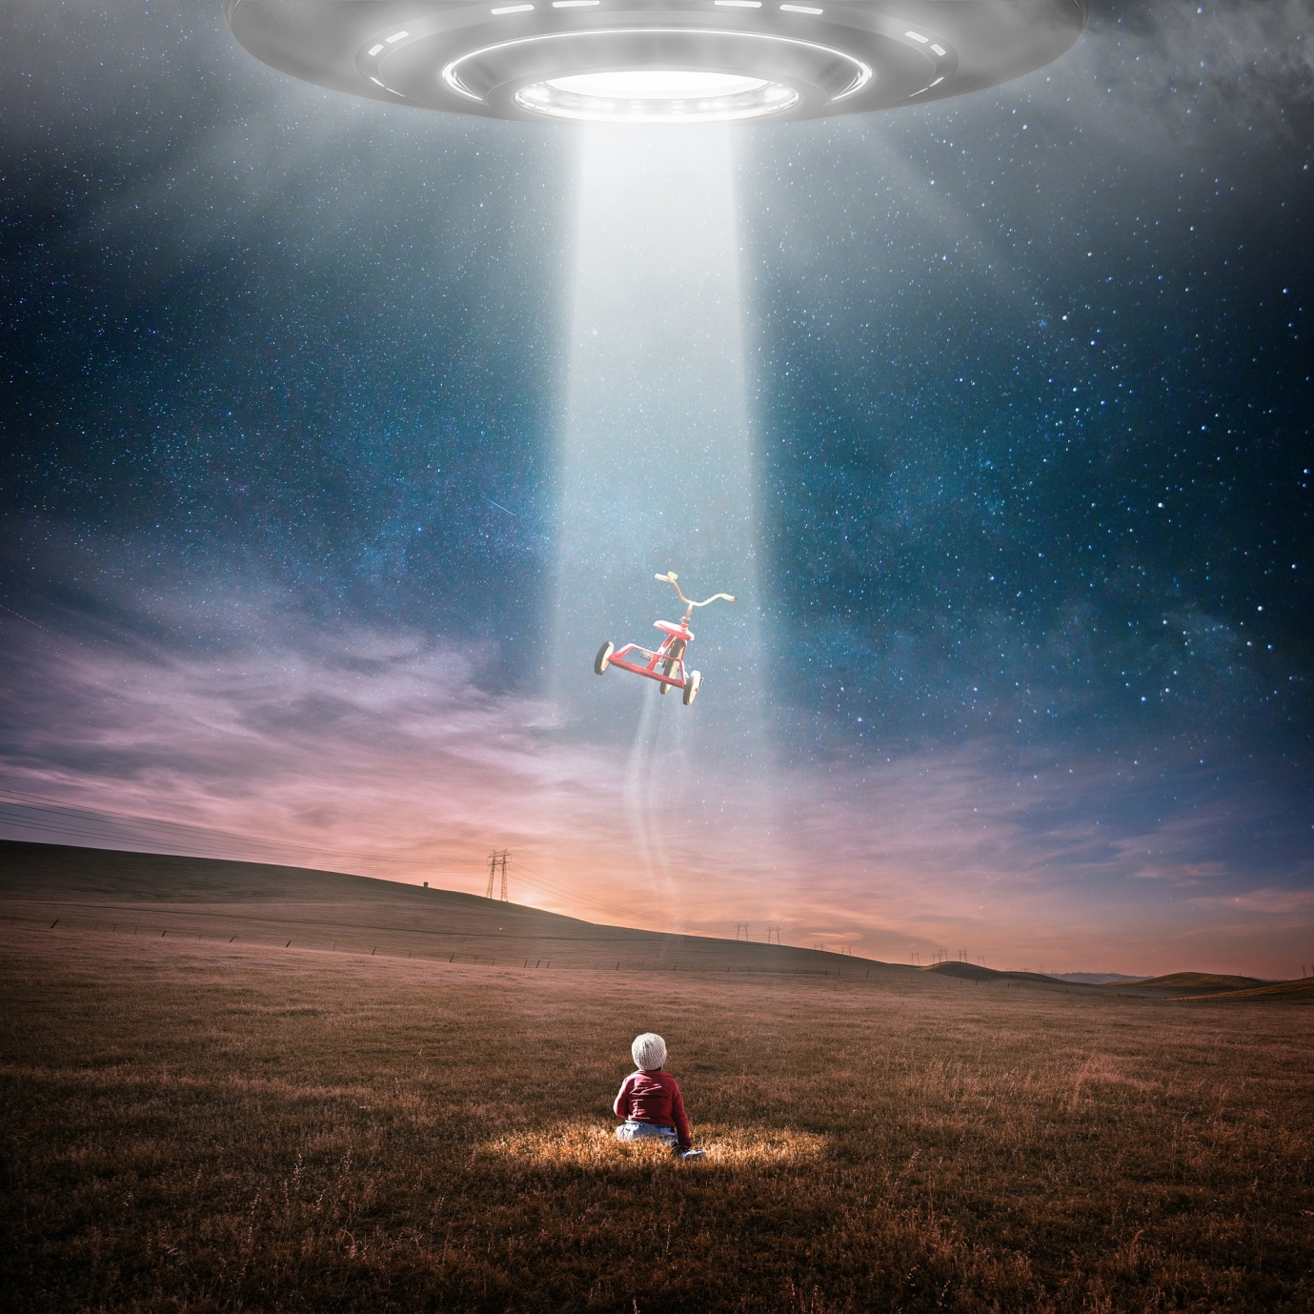

Maths
Monday | Tuesday | Wednesday | Thursday | Friday
Complete the assigned tasks on Mathletics.

As a supplement to mathletics, follow the link to White Rose Maths and you will find a series of lessons, with short videos. Worksheets have been emailed to you. If there are any problems, please let me know. The White Rose resources are excellent and I highly recommend you try to use them at least once or twice a week.
Red, Orange, Yellow Tables: https://whiterosemaths.com/homelearning/year-2/

Green and Blue tables, choose either of these:
https://whiterosemaths.com/homelearning/year-3/
https://whiterosemaths.com/homelearning/year-4/

BBC bitesize also has daily maths activities.

