Wider Curriculum
Below is a list of suggested activities – you may have your own ideas and projects that you want to try.
Make a loose parts skeleton. Create yourself as a skeleton using materials you find outdoors or in the house. How tall does the skeleton need to be lying down? How many ribs? Can you label parts of it using chalk?  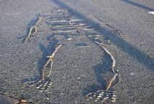 | Complete a family workout at home. Who is the fastest in your family? | .  Have a go at making a stomp rocket. There are instructions attached.
Conversation with a cuddly creature! Most of us have a cuddly toy at home, but what kind of creature is it? Where does it come from? Is the climate hot or cold? What does he or she eat? Where do they live – what kind of habitat do they really live in? Use books and the internet to research about your animal and maybe write a factfile or poster about him or her. | https://www.youtube.com/watch?v=0xPKS3K84WQ  Follow this link to Rob’s kitchen music lesson. Rob is thinking about pitch in this lesson using objects you can find in your kitchen. Try and order your objects from low to high and have some fun playing your Küchespiel!

