Wider Curriculum
Have a go at the floating egg experiment. |  | 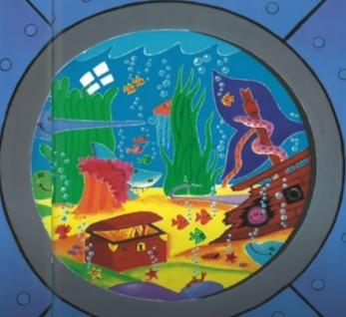  Draw around a plate to make a big circle – use this as your porthole. Draw what you can see in the ocean.
Research your favourite sea creature – it may be the same as you choose for your literacy task – draw a diagram and label the features of the creature. |  |  | Try out the saltwater density experiment.
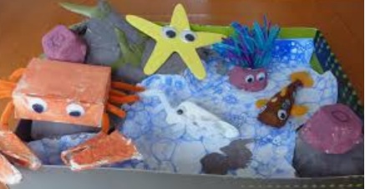  Have a go at making your own rockpool. | Take a walk around your local area and see how the trees and plants have changed over the weeks. How many different colours can you see? List the creatures that you see. |  | Use the powerpoint attached to play the ‘What am I?’ game.

