Wider Curriculum
Below is a list of suggested activities – you may have your own ideas and projects that you want to try.

Spirited Arts Competition  See the attached sheet for the competition requirements.  The competition entry can be drawing, painting, video, sculpture of other media.  There are 5 themes to choose from, most of which we have discussed over this year, including the threat to our earth and inspirational people.  https://www.natre.org.uk/about-natre/projects/spirited-arts/spirited-arts-2020/  Winning entries will be added to the Art in Heaven web gallery. | In the Spring term we learnt about classification categories.  Using the attached sheet, choose a habitat and investigate 10-20 plants and animals that live there and classify them. | Ann Frank’s day was on the 12th June.  Look at the following website to find out about her life and why she wrote a Dairy.  https://www.annefrank.org/en/anne-frank/go-in-depth/typical-day-secret-annex/
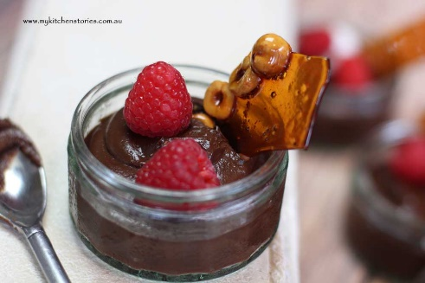
June 26th was National Chocolate Pudding Day. Can you create your own chocolate pudding and send us a photo? The following website has lots of ideas

https://www.bbcgoodfood.com/recipes/collection/chocolate-pudding

Email Mr Hannah @ head@duloeprimary.co.uk or Mrs Wright twright@duloeprimary.co.uk
to let us know what you have been up to.

