Wider Curriculum
Draw and label a map to show where Barry and the other fish go when they are playing. | PE – blow up a balloon or use a ball – how long can you keep it in the air for before it hits the ground?  Make yourself a circular target (bubble) thrown a beanbag or rolled up socks into it to pop it. As you get better take a step further away.
Brilliant Bubbles – Carry out the STEM challenge attached about bubbles. |  |  | 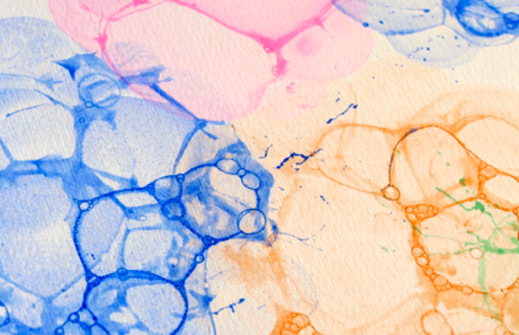  Bubble art Mix your paint with a little water, and a squirt of washing-up liquid, stir it up and then blow into it with a straw to create lots and lots of bubbles. You then gently place the paper over the bubbles to take a print from them, remove, and allow to dry.  Try varying it; For example, you can use several small pots of different coloured bubbles and print them one at a time on the same page, (or cluster them together and do them all at once) to create multi-colour bubble circles.
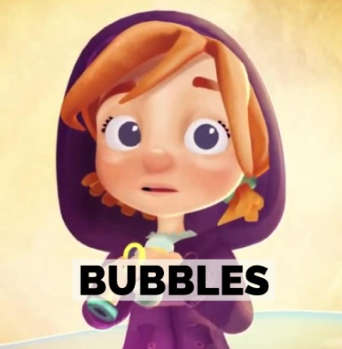  Watch the animation ‘Bubbles’.  Discuss it with a grown up using the bubbles comprehension prompts.  https://www.literacyshed.com/bubbles.html |  | If you could jump into a bubble and be transported somewhere, where would you go? Draw a picture and write a sentence to explain.

