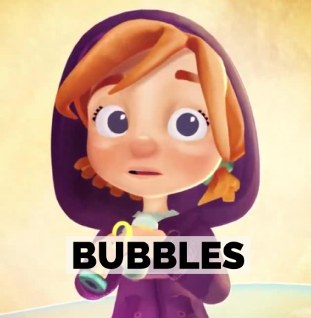
Bubbles – Comprehension

Pause the film at 14 seconds as she picks up the bubbles.
• Ask how is this little girl feeling? How do you know? • How does she feel when she finds the bubbles?
Pause the film after she pulls down her hood and on the bubble.
• How is the feeling now? • What do you think she might be saying to herself? • What colours can you see in this scene?
Pause the film as she sees the yellow fish under the water. 1 min 05 secs
• What can you see? • Can you describe it? • What is it doing? • How is it doing it? • Where is it doing it?
Pause the film once it is in Space at 1 min 17 seconds.
• What can she see? • Can you describe it? • What colour is it? • What is it doing? • How is it doing it? • What else might she be able to see but we can’t see? (moon, aliens etc.)
Pause after she lands on the bubble in the next scene after the big yellow star 1 min 21 secs.
• How is she feeling now? Pause after she spots the girl on the beach. • How is the girl on the beach feeling? • How do you know? • What could have made her feel like this? • How could the little girl in the story cheer her up?
• Discuss what the children liked and disliked about the film.
• Where would you like to go in a bubble?

