Wider Curriculum
Below is a list of suggested activities – you may have your own ideas and projects that you want to try.
Following on from the music workshops, we have been exploring samba music at school. This is a Brazilian type of music so we are basing our learning this week around Brazil. Find out about the Brazilian pop artist Romero Britto and try to recreate some of his work. You could watch these step by step lessons or just look at some of his work and try to recreate it on your own. All you need is some felt tips and paper. There are examples of his work below. https://www.youtube.com/watch?v=CxwJll1uI6I https://www.youtube.com/watch?v=DBEBDexufUM | Learn some samba moves and keep fit at the same time!  https://www.bbc.co.uk/sounds/play/p050f7sj  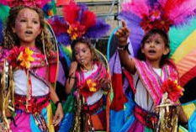 | Find out some facts about Brazil. You can print out the attached sheet if you like. Use an atlas if you have one to find Brazil and mark it on the map.
Read the attached information about Carnival. Design your own costume which could be worn for Carnival. Try and make it as colourful and flamboyant ( ask a grown up what that means or look it up in a dictionary) as you can! | Samba music uses mainly percussion instruments. Make your own instrument to try out some samba rhythms on. It could be a drum, a shaker or a bell!

Examples of Britto’s work:

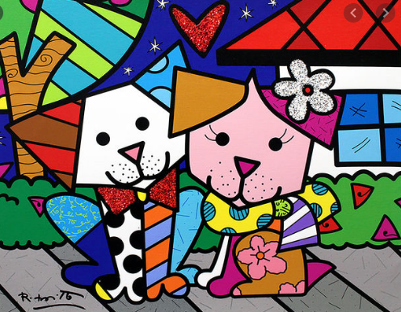
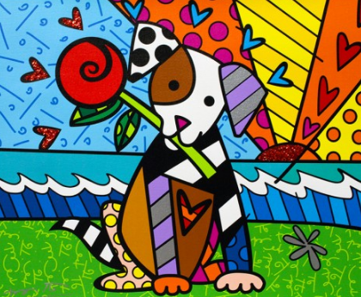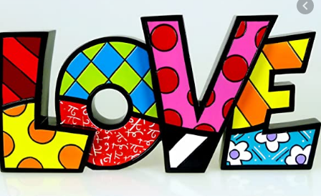

Ideas for samba instruments

