Wider Curriculum
Below is a list of suggested activities – you may have your own ideas and projects that you want to try.

Joseph  In school are learning the story of Joseph. Read the attached story and then see if you can complete the crossword and wordsearch.  We have also been singing the songs, try singing along with Any Dream Will Do on the link below  https://www.youtube.com/watch?v=VeSYfO2mBoI&list=PL8E3FCCAF385DE673&index=17&t=0s | Science  A fun game to play with your family and friends to learn about animal life cycles.  Play the life cycles game at http://www.sheppardsoftware.com/scienceforkids/life_cycle/games.htm | July 4th Independence Day, is a holiday in the United States. Can you find out why and what people do to celebrate this day?
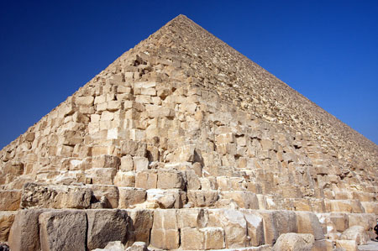
Can you use recyclable materials to make a pyramid, lots of ideas out there on the internet?

Email Mr Hannah @ head@duloeprimary.co.uk or Mrs Wright twright@duloeprimary.co.uk
to let us know what you have been up to.

