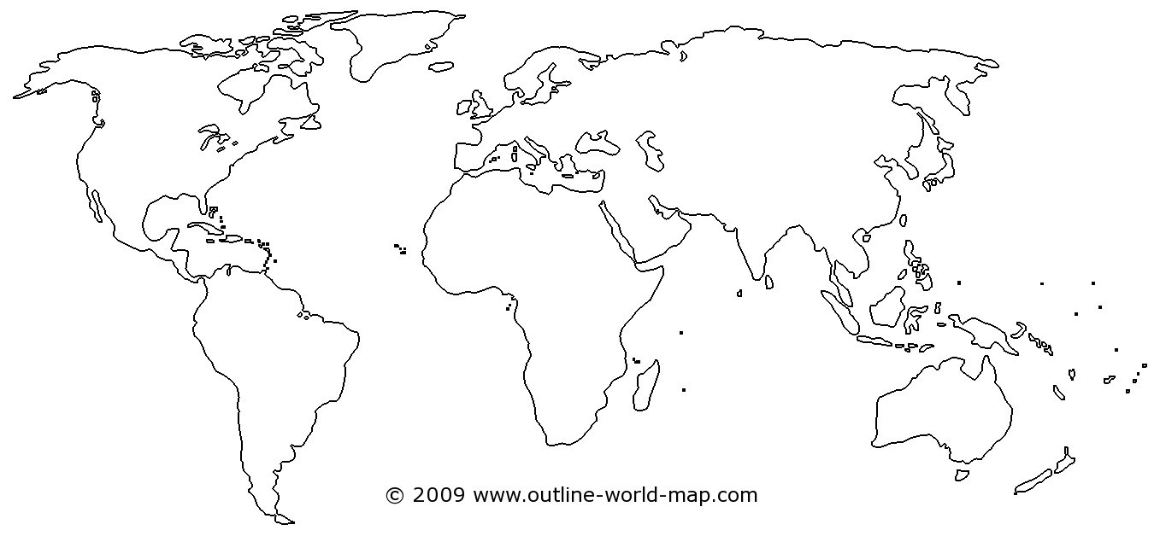

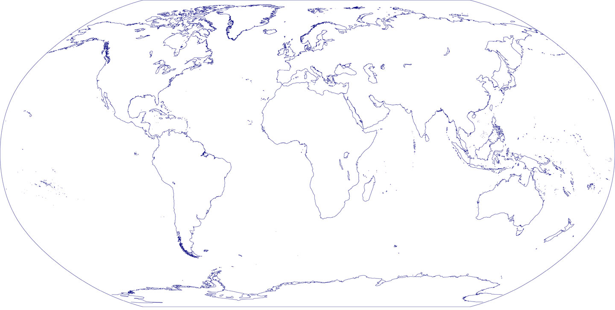

Continents: Africa, Antarctica, Asia, Australasia/Oceania, Europe, North America, South America,

Oceans: Pacific, Atlantic, Indian, Arctic, Southern Ocean