Wider Curriculum
Go on a bug hunt – what can you find? Collect one bug in a pot and look really closely at it. What do you notice? | If I were an insect… Think about which insect you would be and why. Draw a picture and write your answers.
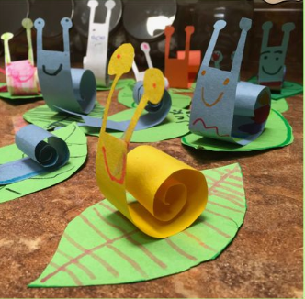  Have a go at making a paper snail. Can you make a whole family? |  | 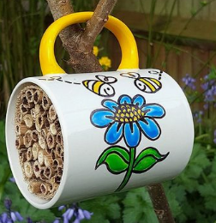  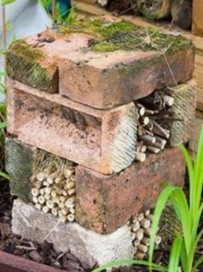  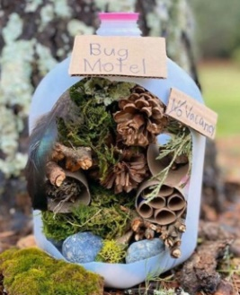  Make a bug home.
Choose you favourite insect, make a fact file all about it. Can you describe its features?

