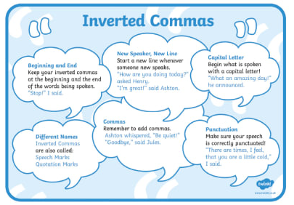

Watch the video @ https://www.literacyshed.com/beans.html

‘From day dot, young Geoff had a curious and unshakeable love for beans.’
It is only fitting then, that when Geoff grows up, he gets a job at the Heinz baked beans factory. As ‘Head of Innovation,’ it is Geoff’s job to create new products in the laboratory. Young and single Geoff realises that a tin of baked beans can be too large for one person and he designs ‘the one for one,’ a tin of beans just right for one person to have as a snack.
One day, Geoff notices a beautiful colleague who works in the Department of Spaghetti, he realises he may need to share his beans so he designs a larger can – ‘The one for two.’ Two soon becomes four, with the introduction of little twin beans and then Geoff realises that he needs ‘The one for all’ tin of beans.

Using the video as a stimulus, write a dialogue between Geoff and his wife. Use the ‘Inverted Commas’ guide above to help punctuate your writing.

