Wider Curriculum
The summer holidays are almost here, so chose a country, anywhere in the world that you wish you could go to on holiday. You might not be going there, but we can dream...! Use this place for the following activities.
Make the flag of your chosen country. You could paint it, collage it or just colour it in.  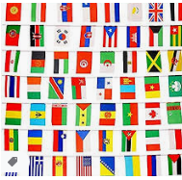 |  | Find a recipe from your chosen country and make it! Is it delicious or a bit yucky?  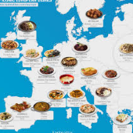 | Draw/paint/ create a famous landmark from your country.  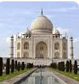  Try and find out where in the country it is. Is it man made or natural?
Listen to some music from your country. Do you like it? How would you describe it? Happy, sad, fast, slow, energetic, upbeat, charming, soothing? Try and think of at least 5 fantastic adjectives. | Use the attached map of the world to label where your country is. You can label the oceans and continents of the world too. What continent is your country in? | Research the language. Learn how to count to 10 ( or maybe 5) in the language and then make up a keep fit workout where you count in the language. E.g. 10 star jumps, 10 sit ups etc.

