Objective: The 7 things that God hates
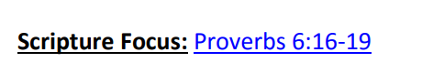
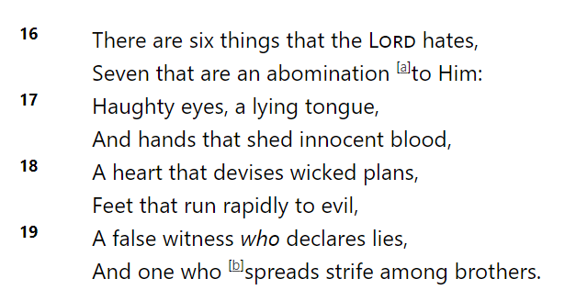
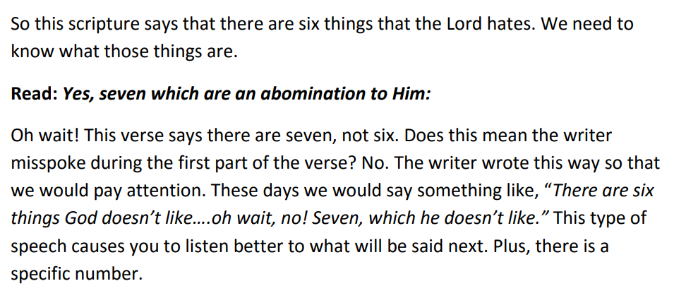
Read Haughty eyes
What does Haughty mean? Proud , What are some examples of having pride or being proud. (I’m the best, putting others down, thinking other people are wrong all the time.)
Read A lying tongue
What is lying? (not telling the truth; manipulating a situation so people believe something isn’t true)
Read And hands that shed innocent blood
What does innocent mean? What does shed blood mean (killed) (this would be a person who has killed someone who did nothing wrong, or did not deserve death)
Read A heart that devises wicked plans
What does devises mean? (to come up with, design, create) God does not like it when we plan bad ideas. Like, planning to be mean to another person.
Read Feet that run rapidly to evil
What does this mean? (Choosing to join in when friends are doing something wrong instead of walking away)
Read A false witness who utters lies
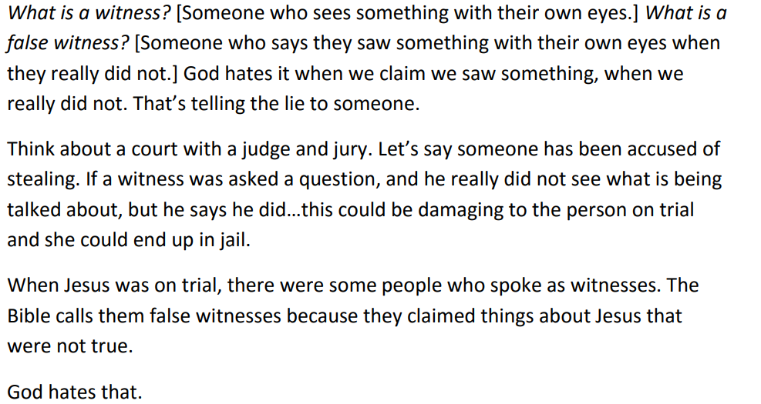
Read And one who spreads strife among brothers
Causing strife among brothers means causing a terrible fight, or disagreements, in the family or community.

Draw a body and cut out the parts from the attached resources, that do with the 7 bad things and put them on the body.
Then look at the rest of the resources that show how we could change them into positives that God likes.
Draw another body and put the positives on.
This is our bodies from our work in class on Tuesday. Can you make something similar?

