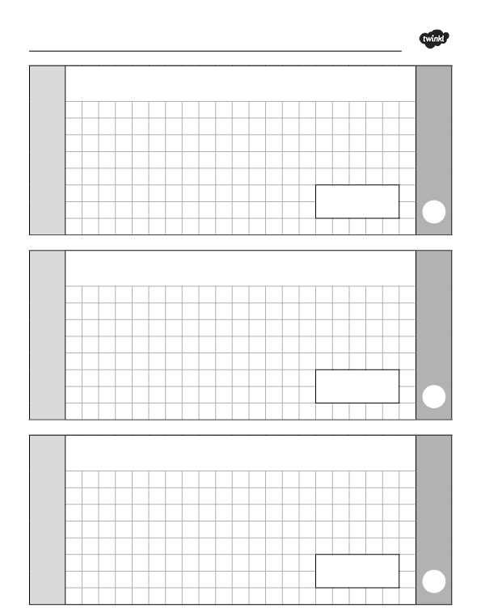

29.01.21

2
0.53 x 6 =
3
1.456 = 1 + 0.4 + + 0.006
1
60% of 32 =
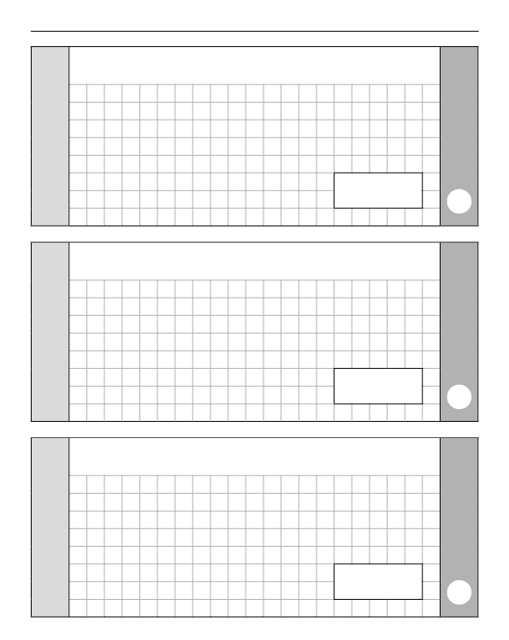
4
22.4 divided by 7 =
5
5

6

Convert 0.8 into a fraction in its simplest form.

Put these in ascending order: 0.6, 61%, 37/50 and 0.66

