Friday 27th January 2021
Home Learning
Maths
For Mrs Wright/Mrs Campbell’s group the learning objective is: Comparing Area

Please watch the video ‘Comparing Area’

Spring Week 4 - Measurement: Comparing Area White Rose Maths

Attached are the accompanying questions and answers.

Slightly different today for Mr Hannah’s group. Attached is a 6 in 6. Please complete as best you can. Then log into TEAMs. Click on ‘Files’ on the top menu bar.
A selection on files will appear. Please select ‘29.01.21 6 in 6’ (the video not word document).
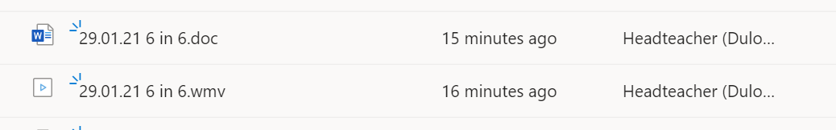
The video will show me explaining the 6 questions on the interactive whiteboard in class. You will then be able to watch this at any time, rewind anything you miss and watch at your convenience.
If there is a question you don’t understand, drop me an email
I have also assigned you all some Mathletics, that I would like you complete hopefully today, or by Sunday evening.

English
I have also tried to change things up a little bit for English today. Below is a link to the governments online school: Oak Tree Academy.
Why did the Ancient Egyptians build the pyramids? (thenational.academy)
They have created a number of lessons about Ancient Egypt. I would like you to watch the 5th video.
You can skip the quiz at the beginning. You will need a pencil and paper. Throughout the lesson there are a number of questions. These same questions will be in our TEAMs quiz today. You could complete the TEAMs quiz as you go along or do it at the end.
We did this in class today and the children really enjoyed it. Good luck.

Religious Education
Please see that attached document.

Physical Education for the week
Monday | Join Joe Wickes for a HIIT workout via the link below  (165) The Body Coach TV - YouTube
Tuesday | Check out the Arena Sports YouTube channel. Arena Sports Coaches have worked a lot at Duloe and the children will recognise lots of the coaches. There is a selection of activities for infant and junior children.  (165) Arena PE and Outdoor Learning at Home - YouTube
Wednesday | Join this live cricket lesson 2.00 – 2.45pm via the link below:  (165) Chance to Shine LIVE! | Super Striker | 27 January 2021 - YouTube
Thursday | Skipping. In this video you will meet Mr Jones, who is a friend of Mr Hannah’s. He is a PE teacher in different primary schools and he put together a range of PE challenges. Today, take on the skipping challenge.  Skipping next level challenge 1 - Bing video
Friday | Dance Zone! Children can take on this dance challenge. Watch the video and see if you can copy the moves… (more infant friendly)  Physical Education KS1 / KS2: Dance Zone - Simple Movement Patterns - BBC Teach

